Earneasy: A mobile Crowd sourcing Application

Software Project lab-3

SPL 3 Mid Report

Course Code: **Software Project Lab III (SE 801)**

**EarnEasy:**

**A Mobile Crowd Sourcing Application**

**Submitted By**

**Pritom Kumar Das**

BSSE 0919

**Supervised By**

**Dr. Md. Shariful Islam**

Professor

Institute of Information Technology

University of Dhaka

**Submission Date: 23 February, 2021**



Institute of Information Technology

University Of Dhaka

LETTER OF TRANSMITTAL

23 February, 2020

BSSE 4th Year Exam Committee

Institute of Information Technology

University of Dhaka

**Subject:** Submission of midreport of “EarnEasy: A Mobile Crowdsourcing Application”.

Dear Sir,

With due respect, I am pleased to submit the final report of Software project lab-III on “EarnEasy: A Mobile Crowdsourcing Application”. I have tried my best to deliver a good report. However, it might lack perfection. So, I therefore, hope that you would be kind enough to accept my report and oblige thereby.

Sincerely yours,

Pritom Kumar Das

BSSE 0919

8th Semester

Bachelor of Science in Software Engineering

Institute of Information Technology

University of Dhaka.

LETTER OF ENDORSEMENT

March 5, 2021

BSSE 4th Year Exam Committee

Institute of Information Technology

University of Dhaka

**Subject:** Approval of the Report

This letter is to certify that, Pritom Kumar Das, BSSE 0919, student of Institute of Information Technology, University of Dhaka, has done “EarnEasy: A Mobile Crowdsourcing Application” under my supervision. I have gone through the report. All the information mentioned in this document is true.

I wish him every success in life and hope that he will continue his effort in the future.

SPL Supervisor

**Dr. Md. Shariful Islam**

Professor

Institute of Information Technology

University of Dhaka

ACKNOWLEDGEMENT

Firstly, I would like to thank the Almighty for helping me complete the final report.

I am grateful to the Institute of Information Technology for giving such a tremendous opportunity to work on “EarnEasy: A Mobile Crowdsourcing Application”. I would like to convey my tremendous gratitude to my supervisor, Dr. Md. Shariful Islam, Professor, Institute of Information Technology, University of Dhaka, for providing me guideline about how I can prepare this report. He helped me a lot by sharing his valuable knowledge with me.

Lastly, I would like to thank my classmates. They have always been helpful and provided valuable insights from time to time.

Abstract

This document contains the software requirements and specifications, architectural design and user interface design, implementation details, testing and user manual of “EarnEasy: A Mobile Crowdsourcing Application”. Mobile crowdsourcing is an emerging technology that has enormous potential in Bangladesh. It is a term that describes crowdsourcing activities that use information collected through smartphones or other mobile devices. Companies such as Pathao, Uber, Food Panda, Sohoz are tapping into this potential to proliferate their business. However, this is only a tiny portion of what can be done using mobile crowdsourcing. With mobile crowdsourcing we can tackle the issue of lack of communication between companies and users. The goal of our project is to help the companies to get the opinion of the crowd regarding the usage, storage, purchase of their products with a simple, reliable and trustworthy method. Thanks to various useful smartphone features, including reliable GPS, excellent cameras, as well as the easy availability of smartphones; users can work on crowdsourcing tasks without almost zero difficulties. The companies can provide any task for example stock checking, user feedback of items or surveys, just-in-time checking on product situations or other simple tasks that can help with the company’s growth, prestige, popularity or profit to the users of the application. As a simple task it does not need any device other than a smartphone. The users will complete the task to earn the financial benefits that the companies offer. It will create a large body of working people and help mitigate the problem of unemployment in our country. In the era of Digital Bangladesh this project can become the gateway that connects both the companies and people. This way the companies and the users both can gain benefits through a mutual win-win situation. This document can be followed to develop a mobile crowd sourcing application.

Table Of Contents

**Chapter 1 :** INTRODUCTION 1

**1.1** PURPOSE 1

**1.2** SCOPE 2

**1.3** ASSUMPTIONS 2

**1.4** DEFINITIONS 2

1.4.1 Mobile Crowdsourcing 2

**Chapter 2 :** ELICITATION 3

**2.1** INTRODUCTION 3

**2.2** ELICITING REQUIREMENTS 3

**2.3** QUALITY FUNCTION DEPLOYMENT 3

2.3.1 Normal Requirement 4

2.3.2 Expected Requirement 4

2.3.3 Exciting Requirement 5

**2.4** USAGE SCENARIO 5

**Chapter 3 :** SCENARIO BASED MODELING 8

**3.1** USE CASE DIAGRAM 8

**Chapter 4 :** DATA-BASED MODELING 17

**4.1** DATABASE 17

4.1.1 Continuous Availability 17

4.1.2 Low Latency Rate 17

4.1.3 Easy Scalability 17

4.1.4 Ability to handle changes 18

**4.2** ER DIAGRAM 18

**Chapter 5 :** CLASS BASED MODEL 19

**5.1** ANALYSIS CLASSES 19

**5.2** CRC CARD 20

**5.3** UML 26

**Chapter 6 :** ARCHITECTURAL DESIGN 27

**6.1** ARCHITECTURAL CONTEXT DIAGRAM 27

**6.2** REFINE THE ARCHITECTURE INTO COMPONENTS 28

**Chapter 7 :** MAPPING REQUIREMENTS TO SOFTWARE ARCHITECTURE 29

**Chapter 8 :** Methodology 31

**8.1** ANDROID APPLICATION DEVELOPMENT 31

8.1.1 Android Application Company 31

8.1.2 Android Application Member 31

8.1.3 Problems Faced During The Android Application Development Process 31

**8.2** HEURISTIC FUNCTION DEVELOPMENT 32

8.2.1 Distance 33

8.2.2 Current Number of Task 33

8.2.3 User Level 33

8.2.4 User Rating 33

8.2.5 Household Earning 34

8.2.6 Educational Level 34

8.2.7 Employment Status 34

**8.3** IMPLEMENTATION TOOLS 34

8.3.1 Android Studio 34

8.3.2 Visual Studio Code 35

**8.4** TECHNOLOGY AND LANGUAGE 35

8.4.1 Flutter 35

8.4.2 Dart 35

8.4.3 TypeScript 35

8.4.4 Firebase Cloud Functions 35

8.4.5 Firebase Cloud Messaging 36

**Chapter 9 :** Testing 37

**9.1** Plan Identifier 37

**9.2** Introduction 37

**9.3** Features to be Tested 37

**9.4** Features not to be tested 37

**9.5** Approach 38

**9.6** Item Pass/Fail Criteria 38

**9.7** Test Deliverables 38

**9.8** Scheduling 38

**9.9** Planning Risks and Contingencies 38

**Chapter 10 :** CONCLUSION 41

**Chapter 11 :** USER MANUAL 42

**11.1** MEMBER APPLICATION 42

42

**11.2** COMPANY APPLICATION 64

REFERENCES 73

**List Of Figures**

Figure 1 EarnEasy Service Usage Senario 5

Figure 2 Level 0 of EarnEasy System 10

Figure 3 LEVEL 1 OF EARNEASY SYSTEM 11

Figure 4 LEVEL 1.1 OF EARNEASY SYSTEM 12

Figure 5 LEVEL 1.2 OF EARNEASY SYSTEM 13

Figure 6 LEVEL 1.3 OF EARNEASY SYSTEM 14

Figure 7 LEVEL 1.4 OF EARNEASY SYSTEM 15

Figure 8 LEVEL 1.5 OF EARNEASY SYSTEM 16

Figure 9 ER Diagram of EarnEasy System 18

Figure 10 UML Of EasrEasy System 26

Figure 11 ARCHITECTURAL CONTEXT DIAGRAM of Earneasy System 27

Figure 12 Componets Of the EarnEasy System 28

Figure 13 Architecture of EarnEasy System 29

Figure 14 Sign In Select PAge 42

Figure 15 Sigin With Google 43

Figure 16 Sign in with Email 44

Figure 17 Registration Page 45

Figure 18 Locaton Permission 46

Figure 19 Home page 47

Figure 20 Navigaton Bar options 48

Figure 21 Navigation Bar 48

Figure 22 Side Drawer 49

Figure 23 Profile Page 50

Figure 24 Theme Page 51

Figure 25 Notification Page 52

Figure 26 Available Task Page 53

Figure 27 Notification With Notificaiton 54

Figure 28 Start Task 55

Figure 29 Task List Page 56

Figure 30 Submit and Review check 57

Figure 31 Error function check 58

Figure 32Free Text Task 59

Figure 33 Multiple Choice task 59

Figure 34CheckBox Task 60

Figure 35 Dropdown Task 60

Figure 36 Device camera Permission 61

Figure 37 Camera select 61

Figure 38 Image manipulation 62

Figure 39 Option for Image 62

Figure 40 Task Submit 63

Figure 41 Task List after task completeion 63

Figure 42 Home Page (Company) 64

Figure 43 Create Task page 65

Figure 44 Subtask selection 66

Figure 45 Option selection 67

Figure 46 Task FInal 68

Figure 47Task Review Page 69

Figure 48 Task Review List 70

Figure 49 Checkbox task Response 71

Figure 50 Dropdown Task Response 71

Figure 51Multiple Choice Task Response 72

Figure 52 Free Text Task Response 72

**List of Tables**

Table 1 Use Case Diagram 9

Table 2 Analysis Classes 19

Table 3 User (Company) CRC Card 20

Table 4 User(Member) CRC CARD 21

Table 5 User(Admin) CRC CARD 22

Table 6 Map CRC CARD 23

Table 7 Account CRC CARD 23

Table 8 Message CRC CARD 24

Table 9 Task CRC CARD 24

Table 10 Database CRC CARD 25

Table 11 System CRC CARD 25

Table 12 Feautres to be tested 37

Table 13 Schedule of Test Plan 38

Table 14 Test Cases Android Application (Company) 39

Table 15 Test Cases Android Application (Member) 40

# INTRODUCTION

This project is aimed to use Mobile crowdsourcing for providing financial benefits to end users and at the same time participating companies or organisations can benefit by seeking knowledge, goods, or services from a large body of people. EarnEasy is a software that will create an efficient , simple and reliable platform to connect the companies and people.

Crowdsourcing is the generalized act of outsourcing tasks, traditionally performed by employees or contractors, to a large group of the Internet population (the wise crowd) by means of an open call. With the great development of smartphones with rich built-in sensors and ratio interfaces, mixing smartphone-based mobile technologies and crowd sourcing offers vast computing resources, and leads to a new paradigm called Mobile Crowdsourcing (MCS). It involves obtaining work, information, or opinions from a large group of people who submit their data via the Internet, social media, and smartphone apps. It allows companies to farm out work to people anywhere in the country or around the world, which lets businesses tap into a vast array of skills and expertise without incurring the normal overhead costs of in-house employees. As an alternative to traditional financing options, crowdsourcing taps into the shared interest of a group, bypassing the conventional gatekeepers and intermediaries required to raise capital. So, this project will aim to create a crowdsourcing platform to connect companies with general populations.

This chapter describes the purpose, scope, assumption, and definitions of the “EarnEasy: A Mobile Crowdsourcing Application” System

## PURPOSE

The purposes of this document are:

* Identify the requirements that have to be carried out as the part of the project.
* Form the baseline for construction of the proposed system.
* Help to reduce the development effort and reveal misunderstandings, and inconsistencies early in the development cycle when these problems are easier to correct.

## SCOPE

The scope of the project is given below:

* This project will work on only android system.
* It will be developed and tested by flutter and android studio.
* The system will only work with image and text.
* The members will use smart phones to run the client side application.

## ASSUMPTIONS

The assumptions of the project are:

* The underlying network is completely reliable.
* User will have reliable internet and GPS connection.

## DEFINITIONS

This report uses the following terminologies in its description.

### Mobile Crowdsourcing

Crowdsourcing is a business model or function that relies on a large group of users as third parties for outsourcing certain tasks. Mobile crowdsourcing is using smartphones as the medium of crowdsourcing strategies . The popular use of the internet makes communication and coordination progressively cheap , tasks that would have been impossible to communicate and coordinate before have become extremely easy to set up and coordinate.[2][3] Crowdsourcing can add significant value to a product or service, and can also generate valuable connections between the users and the company.[4] Crowdsourcing is the practice of engaging a ‘crowd’ or group for a common goal often innovation, problem solving, or efficiency. Crowdsourcing can take place on many different levels and across various industries.[5]

# ELICITATION

## INTRODUCTION

Requirements Elicitation is a part of requirements engineering that is the practice of gathering requirements from the users, customers and other stakeholders. Many difficulties were faced, like understanding the problems, making questions for the stakeholders, limited communication with the stakeholders due to a short amount of time and volatility. Though it is not easy to gather requirements within a very short time, these problems have been surpassed in an organized and systematic manner.

## ELICITING REQUIREMENTS

The main task of this phase is to combine the elements of problem solving, elaboration, negotiation and specification. The collaborative working approach of the stakeholders is required to elicit the requirements. The following tasks were done for eliciting requirements-

* Quality Function Deployment
* Usage Scenarios
* Elicitation of work products

## QUALITY FUNCTION DEPLOYMENT

Quality Function Deployment (QFD) is a structured approach to defining customer needs or requirements and translating them into specific plans. It turns subjective quality criteria into objective ones which can be used to design and manufacture the products. This methodology concentrates on customer satisfaction from the software engineering process. The following requirements are identified by QFD-

### Normal Requirement

The normal requirements are generally the objectives and goals that are stated for a product or system during meetings with the user. The presence of these requirements fulfills users’ satisfaction. These are the normal requirements for the project.

* Error free easy accessible system
* User-Friendly Interface
* Android application
* Effective System
* Separate android application for companies.
* Accessible via the Internet.
* Allow valid users to login and logout.
* Restrict access to functionality of the system based upon user roles
* Allow administrators of the system to change provided information and configure parameters of the system
* Allow valid users that log in to use exciting features of application.
* Allow Administrators to delete , modify, add or update any information regarding tasks.
* This application can be used by any android device with connection to internet.
* A dedicated server have to run all the time to help users get information.
* Maintain proper security for all the data.
* Maintain a database of all users and information.
* Allows user option to modify profile or not.
* Allows user option to change language.
* Allows user to contact with admin through email if needed
* Fast loading application.
* Allow valid users assign/find tasks.
* Sort tasks based on money/distance.

### Expected Requirement

These requirements are intrinsic to the product or system and may be so elementary that the customer does not explicitly state them. Their absence will be a cause for significant dissatisfaction. Below the expected requirements for our project are briefly described.

* Payment system integration
* Error-free software
* Map facilities
* Super Admin monitors all activities
* Provide Search Facilities
* No ambiguous feature
* Data backup
* Sending notification to users if necessary.

### Exciting Requirement

These requirements are for features that go beyond the customer's expectations and prove to be very satisfying when present

* Work scheduling based on user merit.
* Showing tasks based on zoom level.
* The user interface should provide appropriate error messages for invalid input or show message if search results are not found.

## USAGE SCENARIO

EarnEasy is a mobile crowd sourcing application. This project will explore the huge untapped potential of mobile crowdsourcing in the context of our country. Our objective is to use mobile crowdsourcing to create an application that connects both the users and the companies. We want to create a workable, sustainable and maintainable crowdsourcing platform to create opportunities for both individuals and companies alike to use crowd engine.

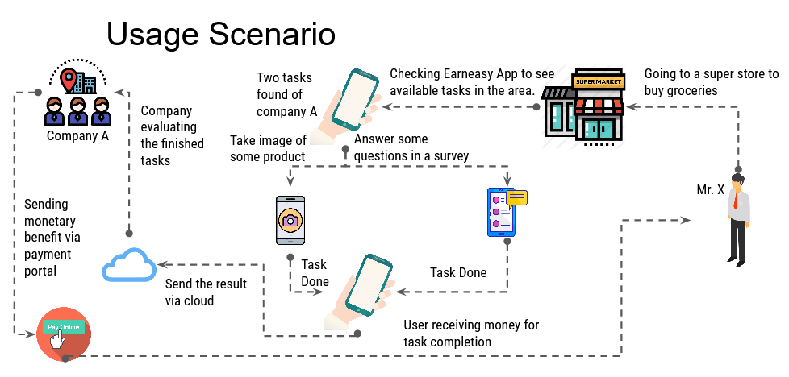

Figure EarnEasy Service Usage Senario

Imagine a simple situation, Mr. X went to a grocery shop to buy some groceries for his family. He opened the EarnEasy app to check the tasks available in the area. He can accept tasks that require him to take some pictures of a particular product or talk to the shop employee about its price or other qualities. After doing some tasks he can upload the photos to the task provider via EarnEasy or answer a simple survey to best describe his experience. This way Mr. X earns some money in the midst of doing groceries. This is just one of the uses of mobile crowdsourcing. As the use of smartphones is becoming more and more popular, the practical use of mobile crowdsourcing becomes more apparent.

EarnEasy will connect the companies and the users. The companies can provide tasks or surveys with adequate payment, work description and location for the task. Through the app the users can search for the available tasks in any area or near their location. The users will need to get to the designated area to accept and start a task. The user location can be traced by using the GPS of the smart phone. Tasks will be very simple like taking some pictures of some products or completing a survey and answering some questionnaires. After completing the tasks, the user can send the necessary images via the mobile app. It will have certain time limit. The companies then can compare the documents with their requirements. If okay, the companies can send the money through the payment service of the application. Otherwise, they can give further instructions. The members can receive money through the payment portal and can send complaint in case of any delay or miscommunication. To maximize data connectivity, we will use Firestore servers. We will record all transactions to prevent any miscommunications. For better location service we will use Google Maps.API. Many services will be provided to the users of the application. Notification will be sent in case of any task, payment or account issues. There will be two major types of service based on the type of the user.

**Company Features**

The registered companies will be verified before they can use EarnEasy services. Companies that use our app will be entitled to many services. Such as -

**Privilege of issuing tasks -** Companies can issue any task that they want. They can issue the task multiple times in multiple places. They can also choose to restrict the tasks according to the level of members.

**Count members in a given area -** The companies can not see the location of an individual member but can see the number of members in a given area.

**Task rights -** Companies retain the rights to change, stop, delete or invalidate any task that they have issued.

**Rate Member Performance -** They can rate the member based on their task completion.

**Member Features**

Normal users or members will be entitled to many services. Such as -

**Accept any task -** Members can accept any task according to their choice.

**Sort tasks -** Members can sort tasks according to payment, area, difficulty, distance etc.

**Anonymity -** Members are anonymous to the companies.  The companies can only see the level and rating of the members.  Their personal information will be hidden.

**Rate task -** The users can also rate the task after completing it.

# SCENARIO BASED MODELING

Scenario based modelling is an inexpensive rapid prototyping technique. This method is effective when systems are being built with the requirements vaguely known at the outset. Users are involved right from the start, to build prototypes evolving towards the final product. The users are also involved with the testing of the prototypes which is essential for the validation of requirements and help the users to gain an initial experience of the final system during the development itself. This method involves techniques which are applied by one or more professionals working alongside users who are expected to provide and specify their requirements at the beginning as well as evaluate and approve the system upon completion. The user (in a passive capacity) and the designer/builder (an active partner) cooperate to reach a working model where the means of communications are by the examination of preliminary models such as the initial narratives, paper models and graphical representations built to represent the final system functions.

This chapter describes Scenario Based Modeling of the EarnEasy: A Mobile Crowdsourcing Application system.

## USE CASE DIAGRAM

A use case diagram is a graphic depiction of the interactions among the elements of a system. The purposes of use case diagrams are:

* Gathering requirements of a system.
* Getting an outside view of a system.
* Identifying external and internal factors influencing the system.
* Showing the interactions among actors.

The first step in writing a use case is to define the set of actors that will be involved in the story. Actors are of two types. They are:

* Primary Actors: Primary actors are the actors using the system to achieve a goal. They both consume data and produce information.
* Secondary Actors: Secondary actors are the actors that the system needs assistance from to achieve the primary actor’s goal. They either consume data or produce information.

Once actors have been identified, use cases can be developed.

Table Use Case Diagram

|  |  |  |  |
| --- | --- | --- | --- |
| Level 0 | Level 1 | Level 2 | :Level 3 |
| EarnEasy System | Account Management | Sign up |  |
| Log out |  |
| Log in |  |
| Update |  |
| Verification |  |
| Delete |  |
| User Management | Company | Authenticate |
| Fill up description |
| Add tasks |
| Create/Provide/Modify work |
| Rate member’s work |
| Verify result |
| Member | GPS check |
| Start task |
| Sort tasks |
| Rate Task |
| Task complete verification |
| Send results |
| Notification Management | Task |  |
| Payment |  |
| Account |  |
| Error |  |
| Payment Management | Payment portal | Send money |
| Receive money |
| Complaint |  |
| Search | Search tasks |  |
| Search member count |  |

**Level 0****: EarnEasy Mobile Crowdsourcing System**

**Primary actors:** Company, Member.

**Secondary actors:** Admin, Database.

**Goal in context:** The diagram shown in figure: 2 represents the whole EarnEasy Mobile Crowdsourcing System.

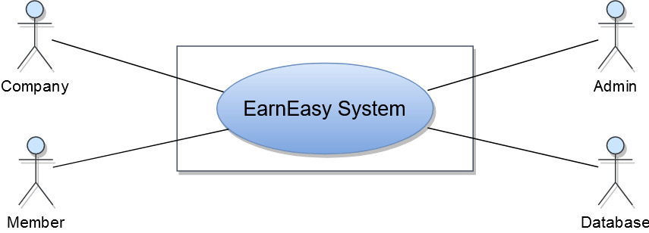

Figure Level 0 of EarnEasy System

**Level 1: Modules of EarnEasy Mobile Crowdsourcing System**

**Primary actors:** Company, Admin, Member.

**Secondary actor:** Admin, Company

**Goal in context:** The diagram shown in figure: 3 shows all the modules of the EarnEasy Mobile Crowdsourcing System.

EarnEasy Mobile Crowdsourcing System consists of 5 modules. They are:

Level 1.1: Account Management

Level 1.2: User Management

Level 1.3: Notification Management

Level 1.4: Payment Management

Level 1.5: Search

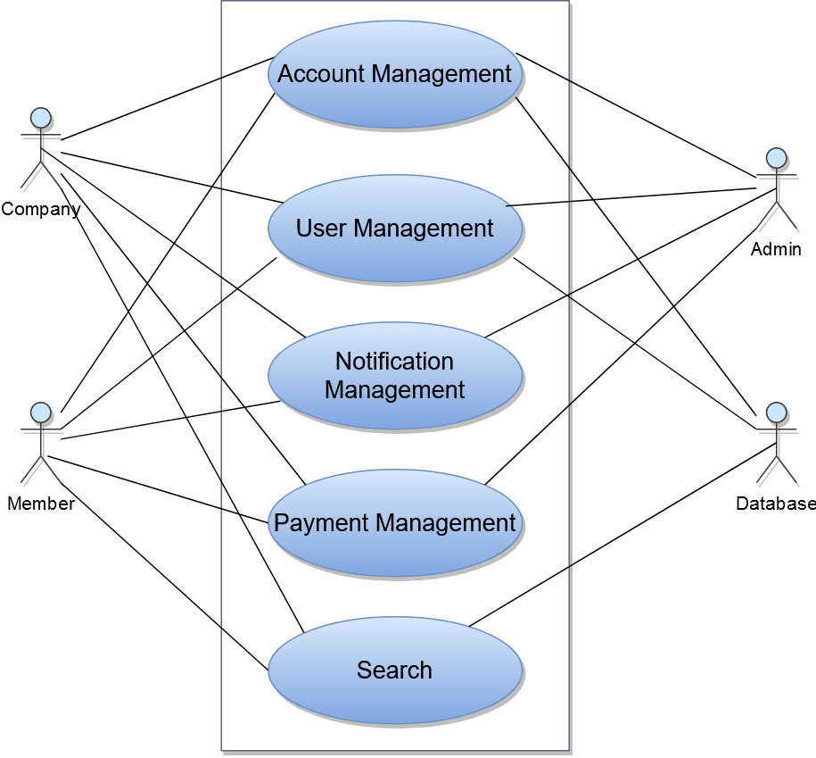

Figure LEVEL 1 OF EARNEASY SYSTEM

**Level 1.1:** **Account Management**

**Primary actor:** Company, Member.

**Secondary actors:** Admin, Database.

**Goal in context:** The diagram shown in figure: 4 refers to the details of the Account Management module oflevel 1.

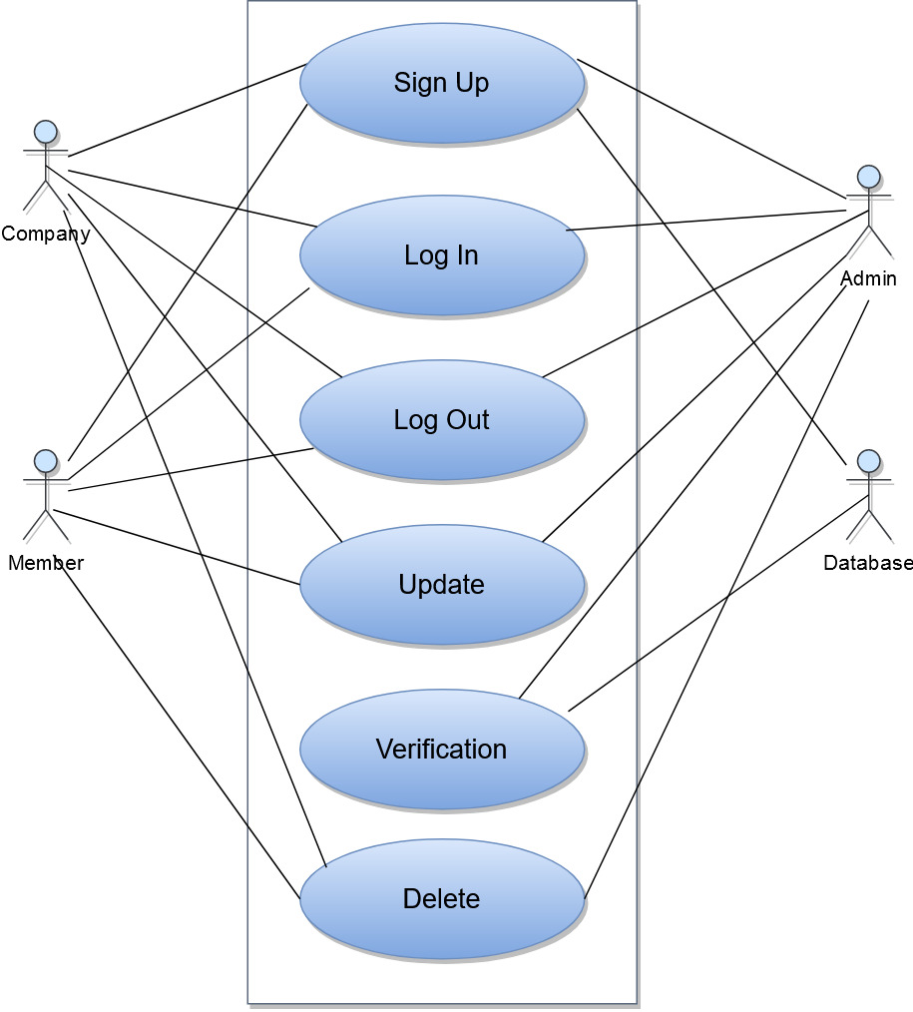

Figure LEVEL 1.1 OF EARNEASY SYSTEM

**Actions and Replies**

A1: User want to sign up/log in/ log out of system.

R1: The admin and database stores the values and provides verification.

A2: User wants to update/delete/change their profile.

R2: System stores those values.

**Level 1.2: User Management**

**Primary actor:** Company, Member.

**Secondary actors:** Admin, Database.

**Goal in context:** The diagram shown in figure: 5 refers to the details of the User Management module oflevel 1.

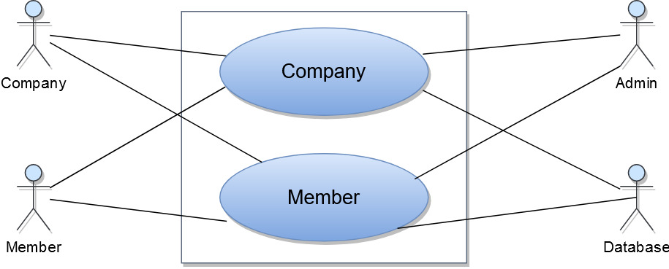

Figure LEVEL 1.2 OF EARNEASY SYSTEM

**Actions and Replies**

A1: Company wants to create task that they need.

R1: The admin authenticates the company and the system stores the necessary data.

A2: Company wants to see the results send by the members.

R2: System sends the result of the particular task created by the company.

A3: The members wants to receive/accept tasks

R3: The system checks members location via GPS and provides the necessary information.

A4: The member completes the task.

R4: System verify the work and send it to the company.

A5: Member want to sort the tasks by distance/payment/title.

R5: System sort the available tasks.

**Level 1.3: Notification Management**

**Primary actor:** Company, Admin, Member.

**Secondary actors:** Company, Admin, Member, Database.

**Goal in context:** The diagram shown in figure: 6 refers to the details of the Notification Management module oflevel 1.

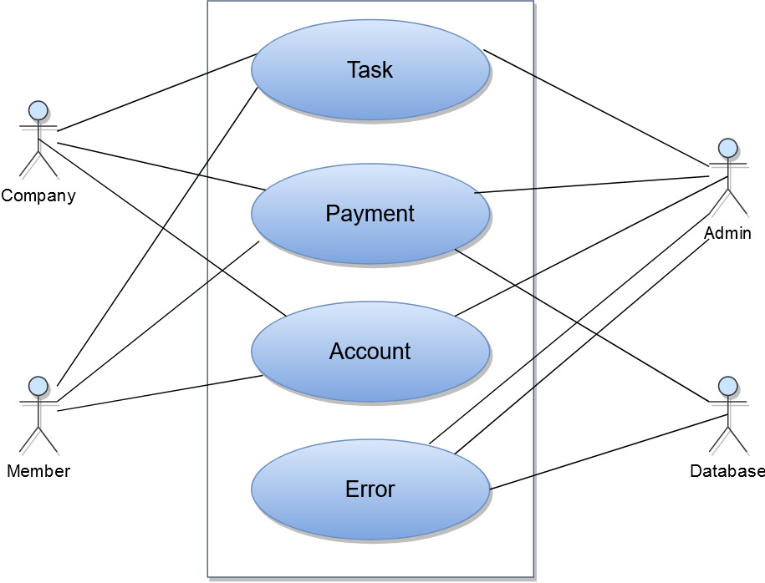

Figure LEVEL 1.3 OF EARNEASY SYSTEM

**Actions and Replies**

A1: User wants to know if the given task is finished/evaluated/complete.

R1: System sends the necessary notification message.

A2: User wants to know the payment conditions

R2: System sends the necessary notification message.

A3: User wants to know account situation.

R3: System sends the necessary notification message.

A4: User wants to know the reason for errors. (If occurs).

R4: System sends the necessary notification message.

**Level 1.4: Payment Management**

**Primary actor:** Company, Member.

**Secondary actors:** Admin.

**Goal in context:** The diagram shown in figure: 7 refers to the details of the Payment Management module oflevel 1.

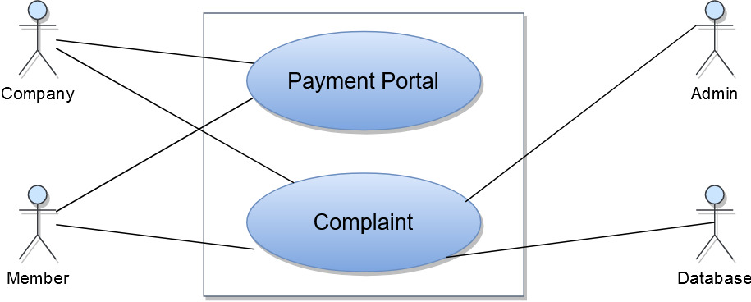

Figure LEVEL 1.4 OF EARNEASY SYSTEM

**Actions and Replies**

A1: Member wants to receive payment for completed task

R1: Company sends the payment via payment portal.

A2: Company wants to send payment for completed task

R2 Member receives the payment via payment portal.

**Level 1.5: Search**

**Primary actor:** Company, Member.

**Secondary actors:** Database.

**Goal in context:** The diagram shown in figure: 8 refers to the details of the Search module oflevel 1.

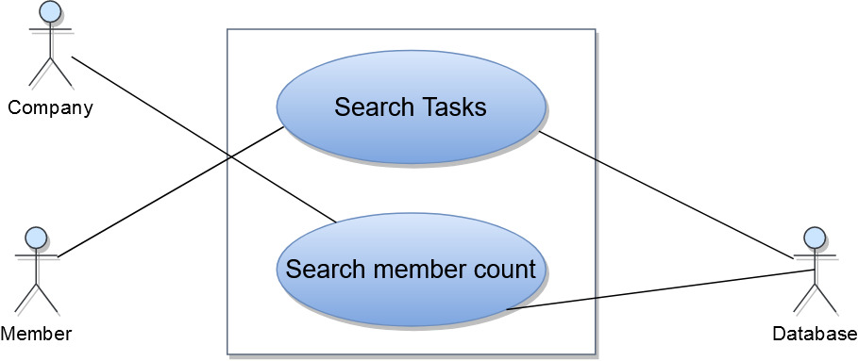

Figure LEVEL 1.5 OF EARNEASY SYSTEM

**Actions and Replies**

A1: Member wants to search for tasks in a given area.

R1: System performs the search according to mobile zoom level.

A2: Company wants to know the number of members in a given area.

R2: System sends the result according to mobile zoom level.

# DATA-BASED MODELING

This chapter presents ER diagram and schema tables of the EarnEasy: A Mobile Crowdsourcing Application System.

## DATABASE

We will use firestore nosql cloud database as our data storing option. NoSQL or the so-called Not-Only SQL database stores the unstructured data in JSON format and provides a unique data storage and access mechanism that is quite different from the tabular relations in RDBMS. These unstructured databases are widely known for their non-relational and schema less data model, improved performance and scalability factors which are always an issue with relational database systems. The NoSQL databases are basically developed to meet the requirements of the modern cloud-based decentralized apps and are a good solution as compared to the relational databases in many ways.

We have decided to use this for the following reasons-

### Continuous Availability

The various relational databases may show up modern to high availability for the data transactions while this is much better with the NoSQL databases which excellently show up continuous availability to cope up with different sorts of data transactions at any point of time and in difficult situations.

### Low Latency Rate

It is easy and less time consuming to derive data from the unstructured data models in the Not-Only SQL databases. Hence, response times with these databases are fast enough and can handle the most intense operations for the applications.

### Easy Scalability

With NoSQL, it’s easy to scale database for current and future requirements. These databases can easily handle data partitioning across multiple servers to meet the increasing data storage requirements. It’s quite affordable to scale a NoSQL database in which inexpensive hardware or servers can be utilized for the purpose as compared to the relational databases which require expensive hardware solutions to meet up the scalability issues arising out of growing needs.

### Ability to handle changes

The schema-less structure of the NoSQL databases helps it cope up easily with the changes coming with time. There is a universal index provided for structure, values and text found in the data and hence, it’s easy for the organizations to cope with the changes immediately using this information.

## ER DIAGRAM

Although we are using noSql database we still need to know the relationship between the data entities. Figure 9 shows ER diagram of the EarnEasy: A Mobile Crowdsourcing Application System.

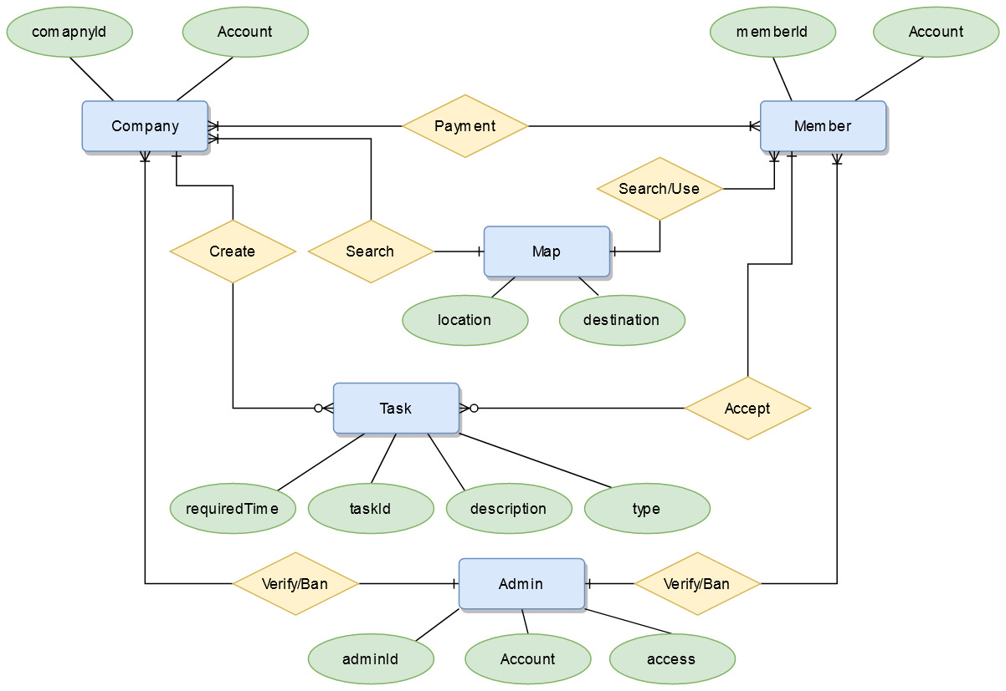

Figure ER Diagram of EarnEasy System

# CLASS BASED MODEL

This chapter describes the class based modeling of the EarnEasy: A Mobile Crowdsourcing Application System.

## ANALYSIS CLASSES

After identifying nouns from scenario, I have filtered nouns belonging to solution domain using General Classification (External entities, Things, Events, Roles, Organizational units, Places, and Structures). Nouns selected as potential class were filtered using Selection Criteria (Retained information, Needed services, Multiple attributes, Common attributes, Common operations, and Essential requirements). After performing analysis on potential classes, I have found the following analysis classes:

Table Analysis Classes

|  |  |  |  |
| --- | --- | --- | --- |
| Serial No | Class name | Attributes | Methods |
| 1 | User (Company) | companyId, Account | addTask(), createAccount() |
| 2 | User (Member) | memberId, Account | startTask(), createAccount() |
| 3 | Admin | Authenticate, | verifyAccount() |
| 4 | Map | Location | showTasks(), searchMembers() |
| 5 | Account | AccountType, | showAccount() |
| 6 | Message | Message body, type | showMessage() |
| 7 | Task | taskType, description, isRequired | showTask(), changeTaskType() |
| 8 | Database | Store, update, retrieve | storeData(), updateData(), retriveInformation() |
| 9 | System | GeneratedQuery, Send, Retrieve | generateSearchQuery(), performRoutineCheck() |

## CRC CARD

The class cards of the analysis classes are given below:

Table User (Company) CRC Card

|  |  |
| --- | --- |
| User (Company) | |
| Attribute | **Methods** |
| companyName  email  level  companyID  companyAddress  certification  writeAccess  city  zipCode  photoUrl  phoneNumber  taskCompletedList | * viewMap() * viewInformation() * viewAccount() * updateAccount() * search() * addTask() * modifyTask() * sendPayment() * signIn() * signOut() * deleteAccount() |
| Responsibilities | **Collaborator** |
| Add Task | Task, Admin |
| Search member count | Database, System |
| Send payment | Member |
| Receive task Result | Database. Member |
| Create Account | Account, Admin |
| Rate member | Database, System |

Table User(Member) CRC CARD

|  |  |
| --- | --- |
| User (Member) | |
| Attribute | **Methods** |
| userID  userName  email  level  address  type  writeAccess  city  occupation  zipCode  photoUrl  phoneNumber  gender  employmentStatus  taskCompletedList | * viewMap() * viewInformation() * viewAccount() * updateAccount() * search() * startTask() * completeTask() * receivePayment() * sendComplaint() * signIn() * signOut() * deleteAccount() |
| Responsibilities | **Collaborator** |
| Start/Complete Task | Task, Admin, Company |
| Search tasks in an area | Database, System |
| Receive payment | Company |
| send task result | Database, System |
| Create Account | Account, Admin |
| Rate task | Database, System |

Table User(Admin) CRC CARD

|  |  |
| --- | --- |
| User (Admin) | |
| Attribute | **Methods** |
| adminID  adminName  password  email  level  address  type  writeAccess  photoUrl  phoneNumber | * viewMap() * viewInformation() * viewAccount() * updateAccount() * searchUser() * banCompany() * banMember() * verifyUser() * signIn() * signOut() * deleteAccount() |
| Responsibilities | **Collaborator** |
| Verify company | Database, System |
| Search user | Database, System |
| Ban User | System, Database |
| Create Account | Account, Admin |

Table Map CRC CARD

|  |  |
| --- | --- |
| Map | |
| Attribute | **Methods** |
| Location ID  Destination  Latitude  Longitude  Area | * showMap() * showTaskLocation() * viewLocation(latlong) * searchTasks() * viewUserlocation() * changeZoomLevel() |
| Responsibilities | **Collaborator** |
| Show map with task location | Database, System |
| Search task location | Database, System |
| Change zoom level | System |
| View user location | System |

Table Account CRC CARD

|  |  |
| --- | --- |
| Account | |
| Attribute | **Methods** |
| ID  Name  Address  Type  writePermission | * createAccount() * update Account() * delete Account() * checkPermission() |
| Responsibilities | **Collaborator** |
| Create/Update/delete Account | Database |
| Check User permission | Database |

Table Message CRC CARD

|  |  |
| --- | --- |
| Message | |
| Attribute | **Methods** |
| MessageID  Description  ErrorMessage | * showMessage() * sendMessage() * notify() |
| Responsibilities | **Collaborator** |
| Notify user | Database, System |
| Show message in case of any event | System |
| Send message as complaint | Member, Admin |

Table Task CRC CARD

|  |  |
| --- | --- |
| Task | |
| Attribute | **Methods** |
| taskId  type  taskDescription  optionList  isCompleted  require  startTime  endTime  requiredTime  access  companyId  importantNote | * addTask() * addTaskType() * createTask() * saveCompanyId() * searchTaskById() * checkAccessLevel() * checkRequiredTime() * checkCompletionStatus() * isRequired() |
| Responsibilities | **Collaborator** |
| Check access level | System |
| Provide task time | Database, Company |
| Search task by Id | Database, System |

Table Database CRC CARD

|  |  |
| --- | --- |
| Database | |
| Attribute | **Methods** |
| store  update  retrieve | * store() * update() * getInformation() * SetInforamtion() * retrieve() * viewInformation() |
| Responsibilities | **Collaborator** |
| Store Information | Admin |
| update Information | Admin |
| Retrieve information | User |
| Perform routine check | System |

Table System CRC CARD

|  |  |
| --- | --- |
| System | |
| Attribute | **Methods** |
| GeneratedQuery  Send  Retrieve | * generateSearchQuery() * send() * retrieve() * showInfo() * formatInfo() * checkUserLocationByGPS() * routineDatabaseCheck() |
| Responsibilities | **Collaborator** |
| Generate search key to database query | database |
| Send information to database | admin |
| Format information to show to user | user |
| Check User Location By GPS | Member |

## UML

This is the UML class diagram of EarnEasy System.

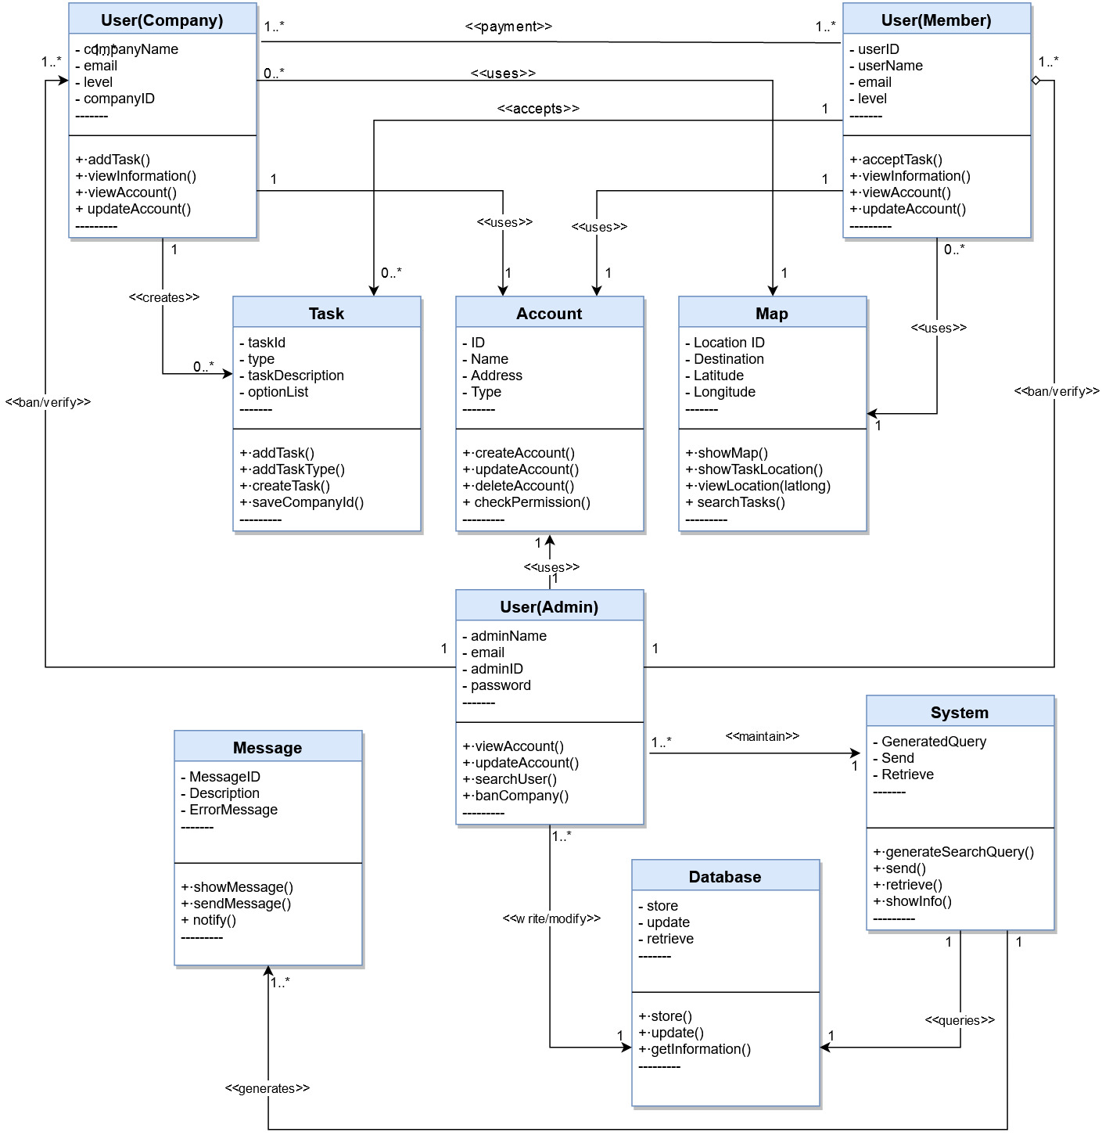

Figure UML Of EasrEasy System

# ARCHITECTURAL DESIGN

As architectural design begins, the software to be developed must be put into context—that is, the design should define the external entities (other systems, devices, people) that the software interacts with and the nature of the interaction. This information can generally be acquired from the requirements model and all other information gathered during requirements engineering. Once context is modeled and all external software interfaces have been described, you can identify a set of architectural archetypes.

This chapter describes architectural context diagram of the EarnEasy: A Mobile Crowdsourcing Application System.

## ARCHITECTURAL CONTEXT DIAGRAM

At the architectural design level, a software architect uses an architectural context diagram (ACD) to model the manner in which software interacts with entities external to its boundaries. systems that interoperate with the target system (the system for which an architectural design is to be developed) are represented as

● Superordinate systems

● Subordinate systems

● Peer-level systems

The following diagram represents the software in context

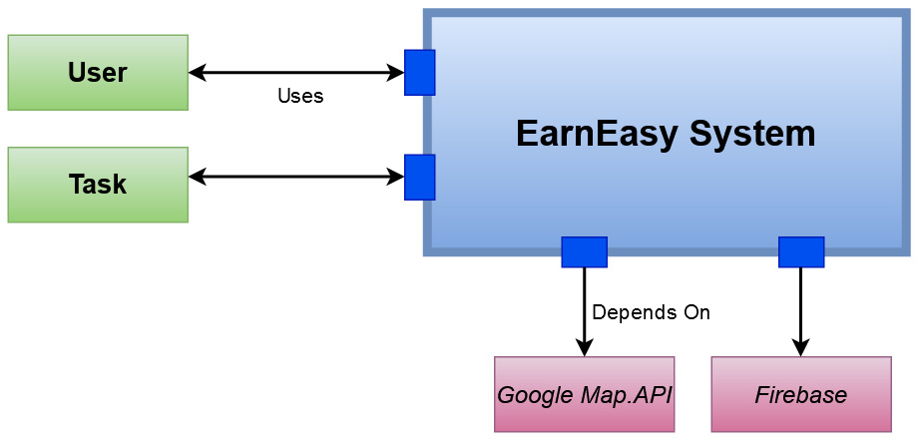

Figure ARCHITECTURAL CONTEXT DIAGRAM of Earneasy System

## REFINE THE ARCHITECTURE INTO COMPONENTS

As the software architecture is refined into components, the structure of the system begins to emerge. The analysis classes introduced in software requirement modeling represent entities within the application domain that must be addressed within the software architecture. Hence, the application domain is one source for the derivation and refinement of components. Another source is the infrastructure domain. The architecture must accommodate many infrastructure components that enable application components but have no business connection to the application domain.

The interfaces depicted in the architecture context diagram imply one or more specialized components that process the data that flows across the interface

For the proposed android application the following components can be introduced:

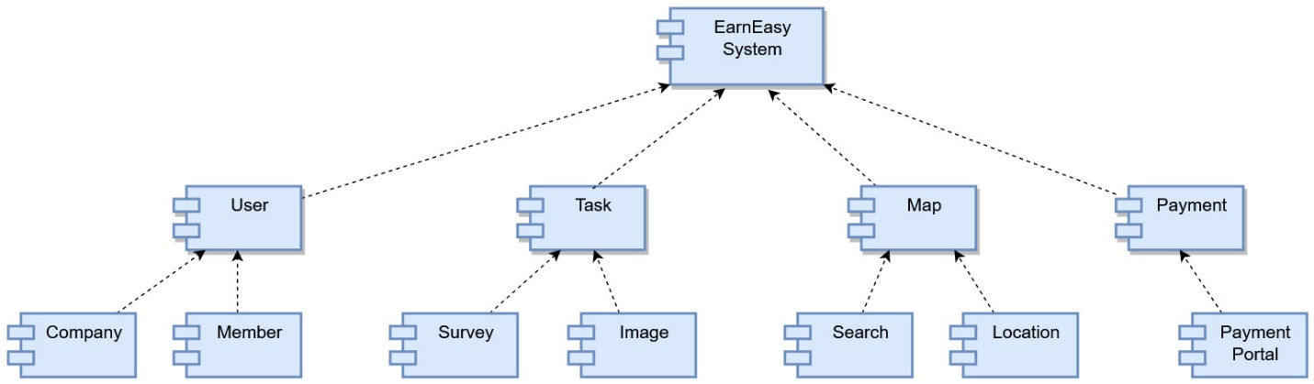

Figure Componets Of the EarnEasy System

# MAPPING REQUIREMENTS TO SOFTWARE ARCHITECTURE

The requirements gathered in the project planning is mapped with the software architecture.

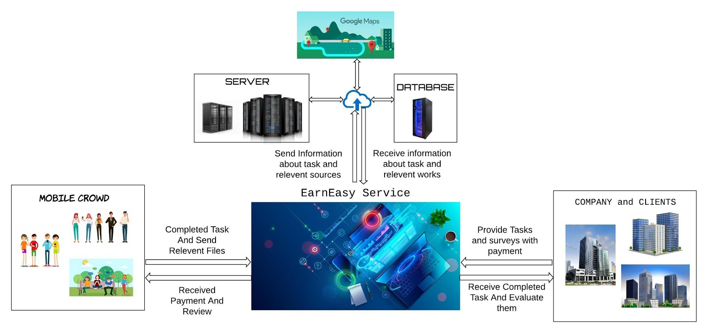

Figure Architecture of EarnEasy System

The following features are mapped into the architecture of the project form requirement analysis.

**All time internet connectivity:** By using googles firstore database we can provide all time connection with the server and as well as data analysis.

**Platform between company and members:** Using flutter to develop the mobile application has enabled us to use smartphone as a crowdsourcing media. And it in turn helps to create the platform.

**Payment:** Payment between company and members are carried through payment portals such as sslcommerz, bkash, sohoz etc

**Task creation and acceptance:** Creation and acceptance of task is achieved by using different roles of users. Such as company and member.

**Super admin support:** Super admin can check all activities and can ban any user that creates problem with firebase architecture. This in turn makes problem solving easier.

**Anonymity of company and members:** Companies are anonymous from the members as their information is not shown to the members. Same way the members achieve anonymity because the companies can not directly view their profile. They can view selected information such as rating and levels.

**Location and distance:** Using google maps.api has enabled us to have a powerful map features in the application. It has also made it easy to implement other features such as searching in a area, getting user current location and other map related features.

**Heuristic function:** With this architectures we are able to get enough data from users to make a suitable heuristic function for assigning task to member and as well as just in time information sharing.

# Methodology

In this project the various project requirements and other features are implemented through many processes. For simplicity we are dividing the whole project into the following two parts.

* Android application development
* Heuristic function development

## ANDROID APPLICATION DEVELOPMENT

For developing the android application we divide the application into two part. The company part and member part.

### Android Application Company

It is developed with flutter language. In this part to log in the company must gain a certificate from our EarnEasy system. We are using firestore as our background database. Companies can issue task here and can check the members count in a given area. It can also issue message to admin in case of any problems. The identity of companies will remain anonymous to the members and members can not access this feature.

### Android Application Member

It is developed with flutter language. In this part the members can become members by using google or email login to see the full list of features available for them. There is no need for certificate from our EarnEasy system. We are using firestore as our background application. Members can apply and accept task here and can see all task in a given area according to their levels. They can also issue complaint to admin in case of any problems. The identity of members will remain anonymous to the companies because companies can only see the information provided by EarnEasy system such as user level and ratings.

### Problems Faced During The Android Application Development Process

* The problem of using crowdsourcing is solved by using smart phones. Because it is highly available to most people.
* Always have internet connectivity is solved by using firebase firestore cloud database. It is horizontally scalable and uses googles optimization.
* Location finding is solved using mobile GPS.
* UI and UX design is implemented with development in flutter. As flutter is highly customizable and useful in rapid development. It is also used to provide maximum coverage with both IOS and Android implementation.
* Creating and storing tasks implemented with firestore .
* Searching task in a specific area is solved using geohashing and geolocation. Geohashing is taking the whole earth as a grid to store information of location. We use flutter GeoFlutterFire library to provide the solution. GeoFlutterFire uses the Firebase Firestore Database for data storage, allowing query results to be updated in realtime as they change. GeoFlutterFire selectively loads only the data near certain locations, keeping applications light and responsive, even with extremely large datasets
* To send the images we use asynchronous function to check the task in memory. And send all the results once the task is completed by user.
* Save memory from big size image we use a heuristic to convert and reduce the size of the images before sending to the data storage. We use flutter image compressor library to tackle the issue.
* For image task the members can take the photos of the products on selves and answer the questions on survey.
* The members can see all the tasks in a selected area. To maximize efficiency the task will be selected according to the zoom level.
* All images taken can be send later if the user has problem with internet connection. But have to finish in time.

## HEURISTIC FUNCTION DEVELOPMENT

For an application like EarnEasy to prosper and flourish it always has to think about the user experience and user satisfaction. For that to happen the core component of task assign between multiple members has to be developed with utmost care and prudence. For this we are using a heuristic model to rate the members and accept task according to their level.

To get the task the members apply for the task and wait to be assigned. To assign the task we take in user relative distance, user task completion history, current task usage, availability, local time, work involvement user level, rating by companies, any case of previous misconduct, number of works done, educational level, work time history and marital status. With these we create a heuristic function to create the likelihood of the members success in the task. Higher performance means high chance to get more valued tasks.

For the heuristic function generation we are evaluating each user that has applied to a task. For this we are using user various user generated attribute such as distance from the task and users’ current location. And how many tasks the user is currently handling. We have given a general upper score for each attribute depending on their importance. Following is the considered attribute and the reasoning for this decision.

### Distance

This is the attribute with highest importance and consideration. This application calculates and shows users how distant they are from a given task. They can take decision based on the distance as it effects transportation and additional cost for going to distant places. Similarly, members close to the task can come more frequently and easily in the mentioned time. For this we have given an upper limit of 500 points for distance. But most of the points are distributed to the 5 kilo meter radius of the task. Members outside this will have little points from this. The relative importance of this is the highest.

### Current Number of Task

The second important point is the number of tasks the member is currently completing. If the user is completing more than 3 tasks at the time, they applied then they are not given the task. The points allocated is 300 for this. It is inversely proportional to the number of task the user is currently doing. This is the very easy to calculate. This way the users that does not have any task at the time will have more priority and the users doing other task can focus on finishing their own task before trying for other task.

### User Level

User level is a very important attribute. This level goes up the more task the user has completed, the more active they are, the quality of their task. It goes down by inactivity, number of task not finished, and disinterest. Members can see the level and attempt to improve it by doing more task. It has an upper limit of 200 points. It is proportional to the user level. So higher level user can get more preference. There can be even task that are visible to users only when they have a certain level. This way the members the rewarded for the amount of time they put in this application.

### User Rating

The company can see the task after the user has completed it. They can give user rating based on the quality of the task. This way members are being responsible for the work they put in. The upper limit for this is 100. As we don’t count the number of tasks reflected in it, this can not have more points. But to maintain their rating the users should give quality work.

These four are the main heuristic function contributor. After we can further filter members based on their personal information and capability. As these attributes are not very important and easy to change we place only 50 points in all of these values.

### Household Earning

Naturally, the more the household earns the less likely the need for earning bonus by doing Earneasy. So the lower earning households have more priority.

### Educational Level

With higher education the probability to firmly do complicated work increases. So, higher education gets slightly better edge.

### Employment Status

The people with full time jobs can spend less time for doing tasks for Earneasy as they have less need. Conversely unemployed people may need it more. So, we placed little more points for the needy people.

This way we create a heuristic score based on the user attributes. The user with highest score gets the task. This is all dynamically maintained by cloud functions. So, the companies don’t have to worry about member selection.

## IMPLEMENTATION TOOLS

### Android Studio

Android Studio is the official integrated development environment (IDE) for Google's Android operating system, built on JetBrains' IntelliJ IDEA software and designed specifically for Android development. It is available for download on Windows, macOS and Linux based operating systems or as a subscription-based service in 2020. It is a replacement for the Eclipse Android Development Tools (E-ADT) as the primary IDE for native Android application development.

Android studio has very great flutter integrated environment. It has various areas where it can help the developer code with snippets. I have used a lot of plugins in android studio to make the production easier. The only problem is that it needs a lot of RAM. Specially if you need to use the integrated emulators of android studio. It that case you will need a minimum of 16 GB ram. In my project I sometimes had to use two emulators concurrently for testing and developing purpose, which was a significant burden for my laptop.

I have used Android Studio version 4.1 in my project.

### Visual Studio Code

Visual Studio Code is a freeware source-code editor made by Microsoft for Windows, Linux and macOS. Features include support for debugging, syntax highlighting, intelligent code completion, snippets, code refactoring, and embedded Git. Users can change the theme, keyboard shortcuts, preferences, and install extensions that add additional functionality.

I have worked with the latest version of 1.55

## TECHNOLOGY AND LANGUAGE

### Flutter

Flutter is an open-source UI software development kit created by Google. It is used to develop applications for Android, iOS, Linux, Mac, Windows, Google Fuchsia, and the web from a single codebase. It uses dart programming language. For this reason, I have used flutter as my programming language and tool.

I have used flutter from version 1.1 to 2.1 as the development progressed.

### Dart

Dart is a client-optimized programming language for apps on multiple platforms. It is developed by Google and is used to build mobile, desktop, server, and web applications. Dart is an object-oriented, class-based, garbage-collected language with C-style syntax. Dart can compile to either native code or JavaScript. This is the backbone programming language of flutter.

### TypeScript

TypeScript is a programming language developed and maintained by Microsoft. It is a strict syntactical superset of JavaScript and adds optional static typing to the language. TypeScript is designed for the development of large applications and trans compiles to JavaScript.

At the last part of my project development, I had to write cloud function for my project. For firebase it only accepts typescript and javascript. So, I had to learn typescript for working in project backend.

### Firebase Cloud Functions

Cloud Functions for Firebase is a serverless framework that lets users automatically run backend code in response to events triggered by Firebase features and HTTPS requests. The JavaScript or TypeScript code is stored in Google's cloud and runs in a managed environment. There's no need to manage and scale users own servers. This is one of the places for server side programming.

### Firebase Cloud Messaging

Firebase Cloud Messaging, formerly known as Google Cloud Messaging, is a cross-platform cloud solution for messages and notifications for Android, iOS, and web applications, which currently can be used at no cost. This is used to send notification to users across platforms. Push notification for users is achieved by this.

# Testing

In this project, we test the system for admin, company and member interaction. In this section, we use black box testing on the system to find any bugs or problems.

## Plan Identifier

On this project we have two android application for company and members. We use firestore noSql database. So we see various data input and output.

* Android Application (Company) Test Plan
* Android Application (Member) Test Plan

## Introduction

This test plan has been developed for “EarnEasy: A Mobile Crowdsourcing Application”. The whole system is created to test on android application with android studio and firebase firecast module for fast connectivity.

## Features to be Tested

The following features are tested:

Table Feautres to be tested

|  |  |
| --- | --- |
| Application | Features |
| Android Application  (Company) | * Authentication * Payment portal * Search member count * Add/Create task with various inputs * Add/Create different types of task * Account |
| Android Application  (Member) | * Authentication * Payment portal * Search task * Accept task with various situation * Account create/remove/modify |

## Features not to be tested

All the features of the system are tested.

## Approach

I used end to end automated (integration) testing technique to test the system as a black box.

## Item Pass/Fail Criteria

If actual output of a test case does not match with expected output of the test case, the test case is considered as failed. 100% of all test cases should pass. No failed case should be crucial to the end-user’s ability to use the application.

## Test Deliverables

I will deliver test plan document, test case and test report.

## Scheduling

Scheduling is given below with different part of Quality Assurance (QA) and duration –

Table Schedule of Test Plan

|  |  |
| --- | --- |
| QA | Duration |
| Test plan | 2 days |
| Testing | 3 days |

## Planning Risks and Contingencies

The following scenarios are considered as risks for the project:

● Delay in requirements engineering.

● Delay in developing.

● Modification in development technology.

Table Test Cases Android Application (Company)

|  |  |  |  |  |  |  |
| --- | --- | --- | --- | --- | --- | --- |
| Android Application (Company) | | | | | | |
| Test Case ID | Scenario | Steps | Input | Expected output | Actual Output | Result |
| 1 | Authenticate using fake account | Trying to log in as company with fake credential | No input | An error message will show as company is not registered | Same as expected output | Passed |
| 2 | Not providing payment after receiving task result | Log in as company, then not paying after receiving task result | No Input | Payment not provided. Then an message showing the payment that is missed. | Same as expected output | Passed |
| 3 | Create / Add task with impossible parameter | Log in as company, then create/ add task with impossible parameter such as wrong location or negative payment or impossible deadline | Task creation parameters. | Provide meaningful parameter and an error message providing the location of the problem. | Same as expected output | Passed |
| 4 | Delete account after receiving work | Log in as company, then deleting account after receiving task result | No input | Send email with the warning printed and inform admin to take legal approach against the company | Same as expected output | Passed |

Table Test Cases Android Application (Member)

|  |  |  |  |  |  |  |
| --- | --- | --- | --- | --- | --- | --- |
| Android Application (Member) | | | | | | |
| Test Case ID | Scenario | Steps | Input | Expected output | Actual Output | Result |
| 5 | Authenticate using fake account | Trying to log in as member with fake credential | No input | An error message will show to log in with valid email | Same as expected output | Passed |
| 6 | Accept task but not completing it. | Log in as member, then not completing accepted task | No input | Warning message will be send and decrease it members level | Same as expected output | Passed |
| 7 | Take on too many tasks in mutually distant areas in the same time frame | Log in as member, then accept too many tasks in mutually distant areas such as some task in Uttara and some task in Azimpur at the same time | No input | Provide warning to the user when accepting task and decrease user level if task is not completed. | Same as expected output | Passed |
| 8 | Tapping task completed option without completing task properly. | Log in as member, then tapping task is completed without finishing the required tasks. | Insufficient inputs for task | Provide warning message that task is not completed and decrease user level if task is not completed | Same as expected output | Passed |

# CONCLUSION

It was so much challenging to prepare a final report for the first time. I think that this report has been written in an easy-to-read way as well as with full information required to have a good concept over the idea. The reader of should easily understand the information of the report.

# USER MANUAL

This is the user manual for this application. This application is divided into two parts. The company application and the member application. There is also backend support with cloud functions to make the user experience smoother. Below are various screenshots and description on its functions.

## MEMBER APPLICATION

This is the member part of the application.

# 

Figure Sign In Select PAge

This is the first after the load screen of the application. The member can sign in using both google sign in and sign in with email.

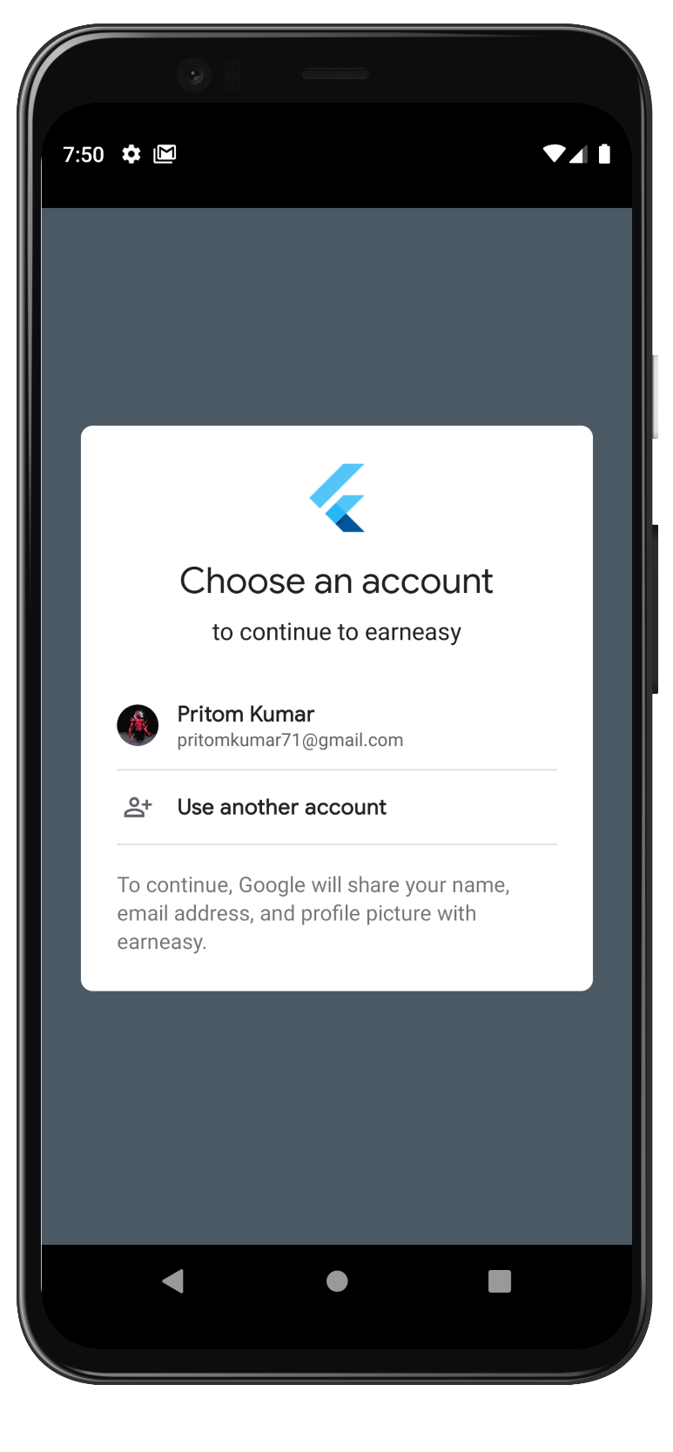

Figure Sigin With Google

This page appears after selecting google sign in option. User can select the option any account if they have multiple accounts.

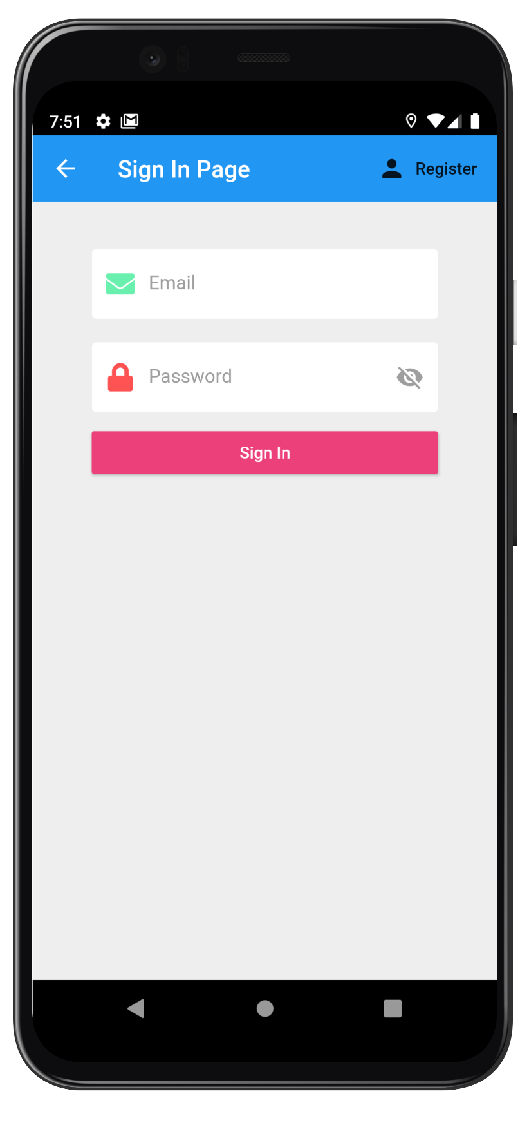

Figure Sign in with Email

If they use sign in with email this page appears. This page has multiple error checking options.

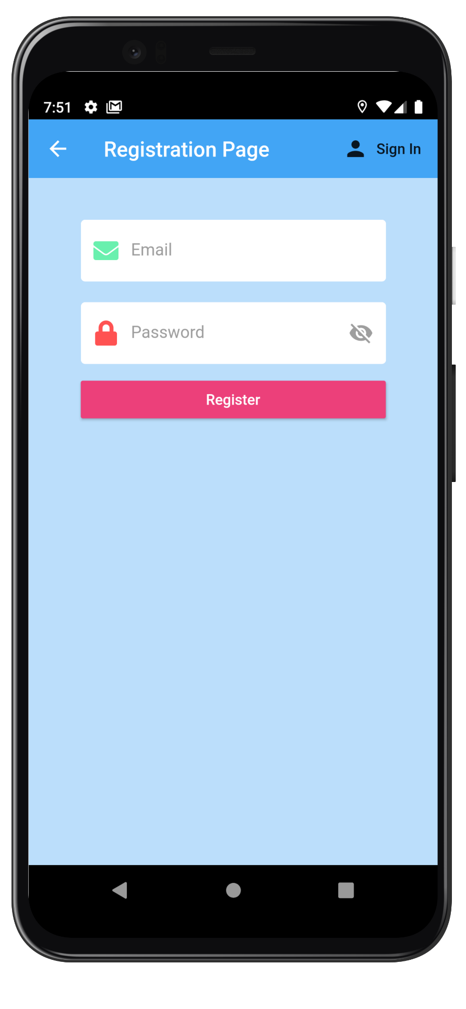

Figure Registration Page

If the user don’t have a account already created, they can register with this page. The sign in and register page is toggle controlled for user experience.

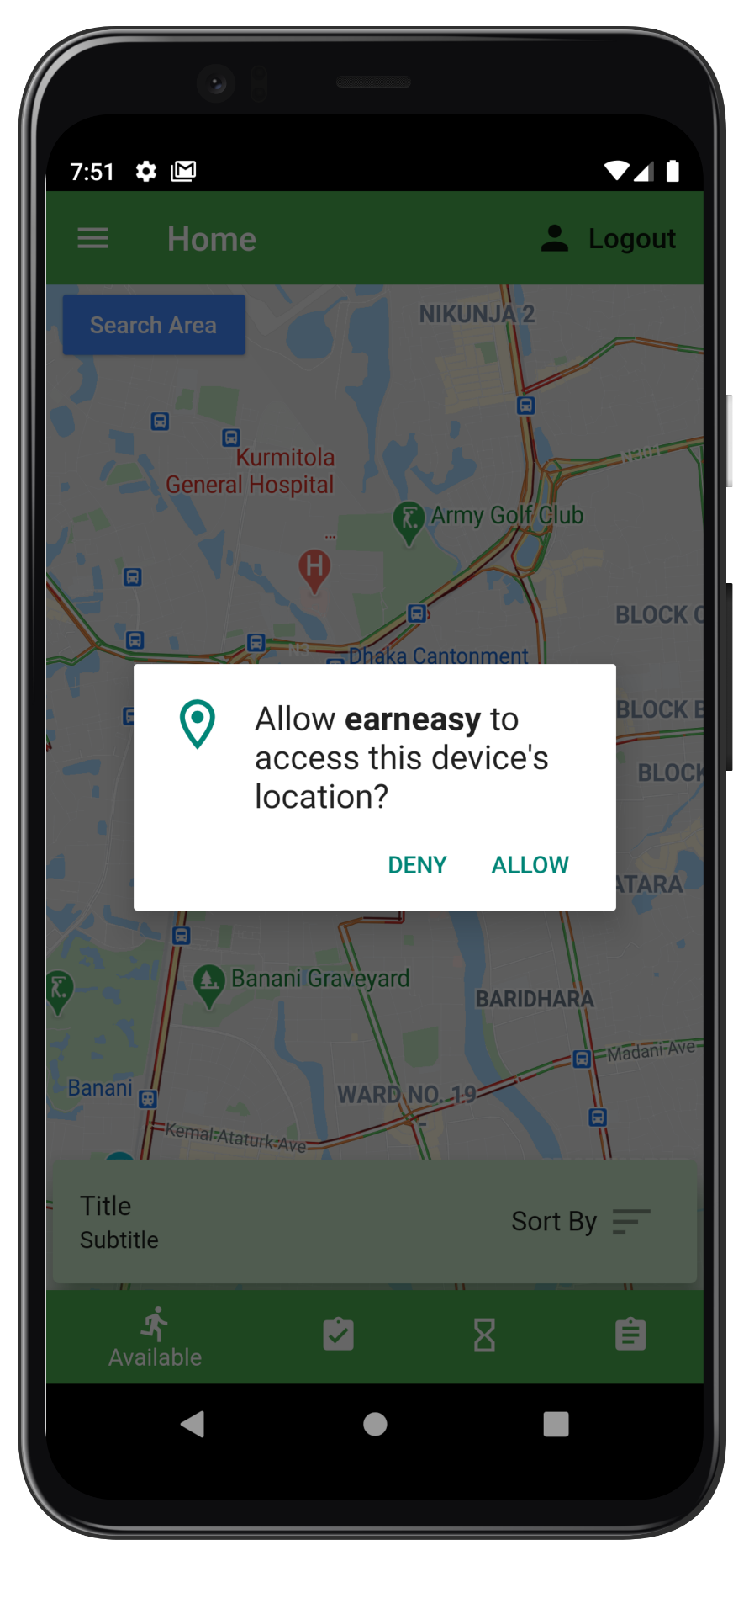

Figure Locaton Permission

After registration the user will be prompted to give permission for GPS use. This is very important because the product heavily depends on users location to calculate distance.

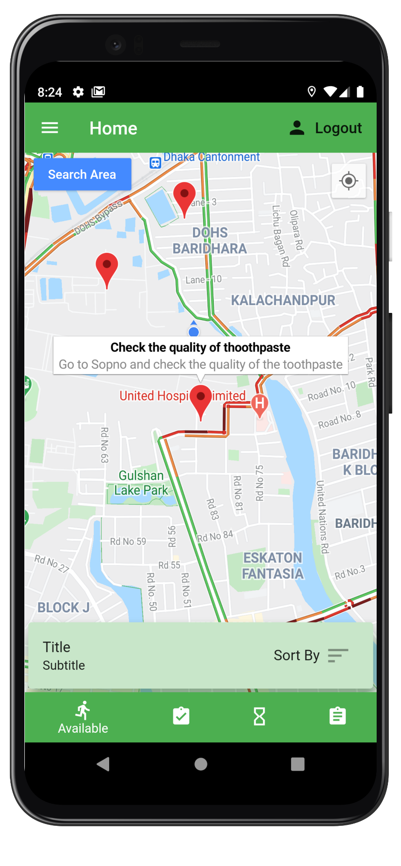

Figure Home page

This is the main page of earneasy. The users can search any area for task and see the task location. Clicking on the points will take the user to the main task page to see the rest of the task. The expandable view stores some description of the tasks. Users can also use the bottom navigation bar to see the available, my tasks, waitlisted tasks and completed tasks.

By expanding the view, the user can see the distance and money for the task. The user can also sort the tasks according to money, distance and title.

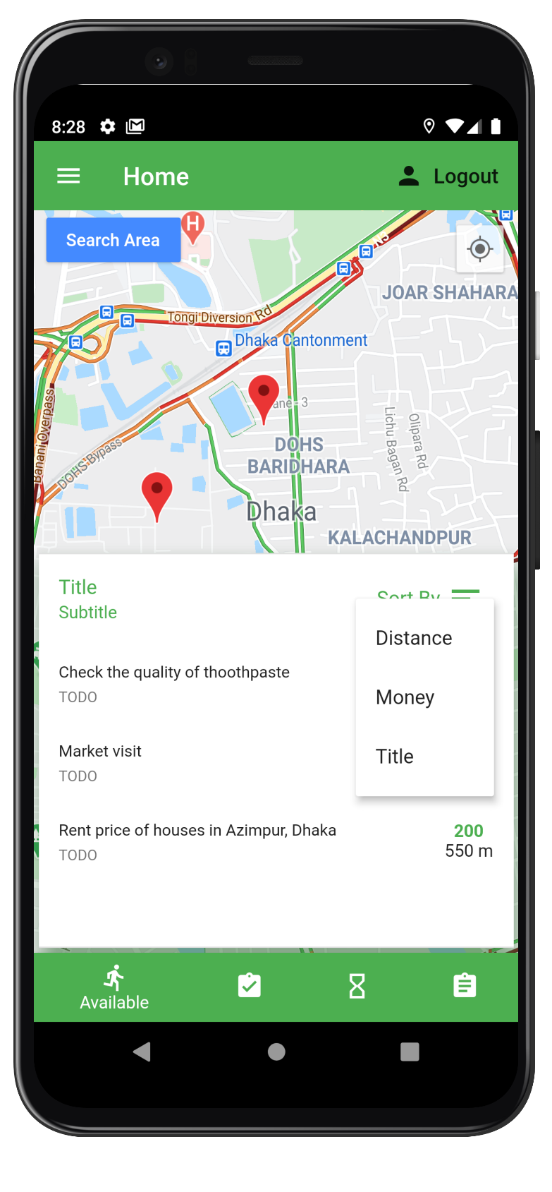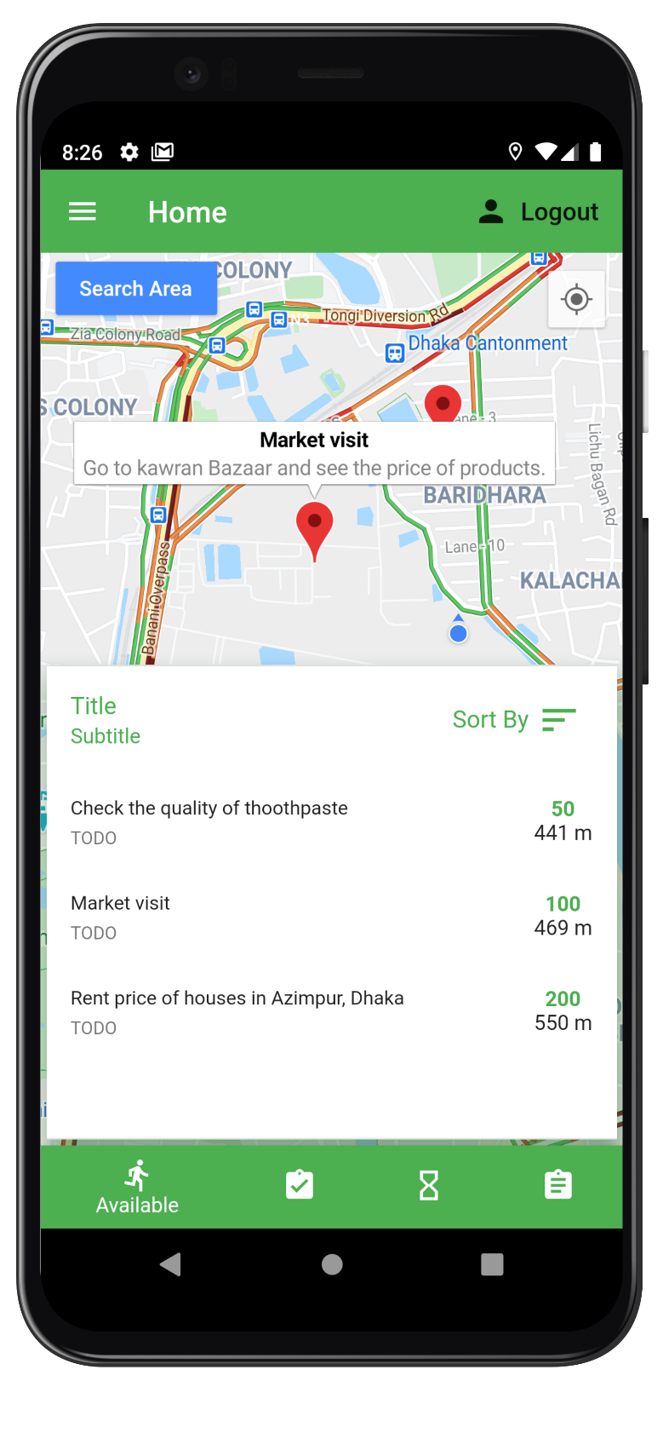

Figure Navigaton Bar options

Figure Navigation Bar

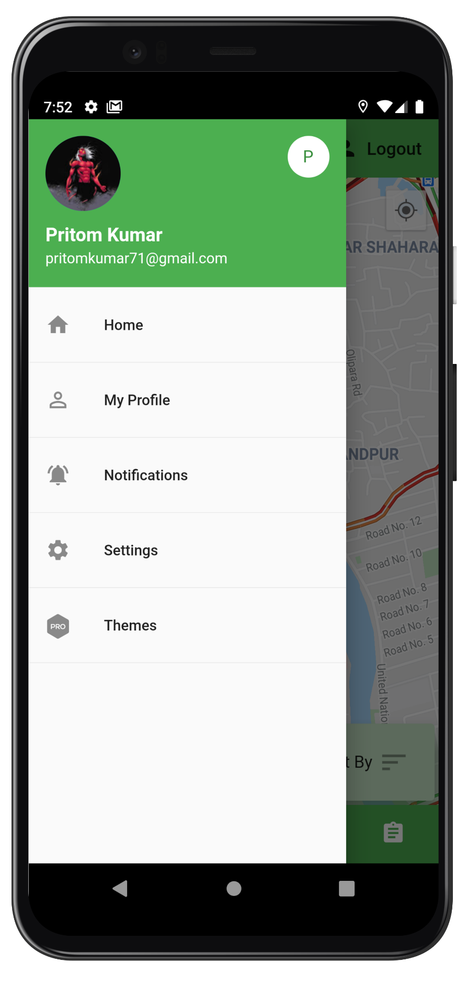

Figure Side Drawer

This is the side drawer of the application. The users can click on the icon of the left corner to pull this tab. This gives easy access to Profile, Notification, Settings and Themes page.

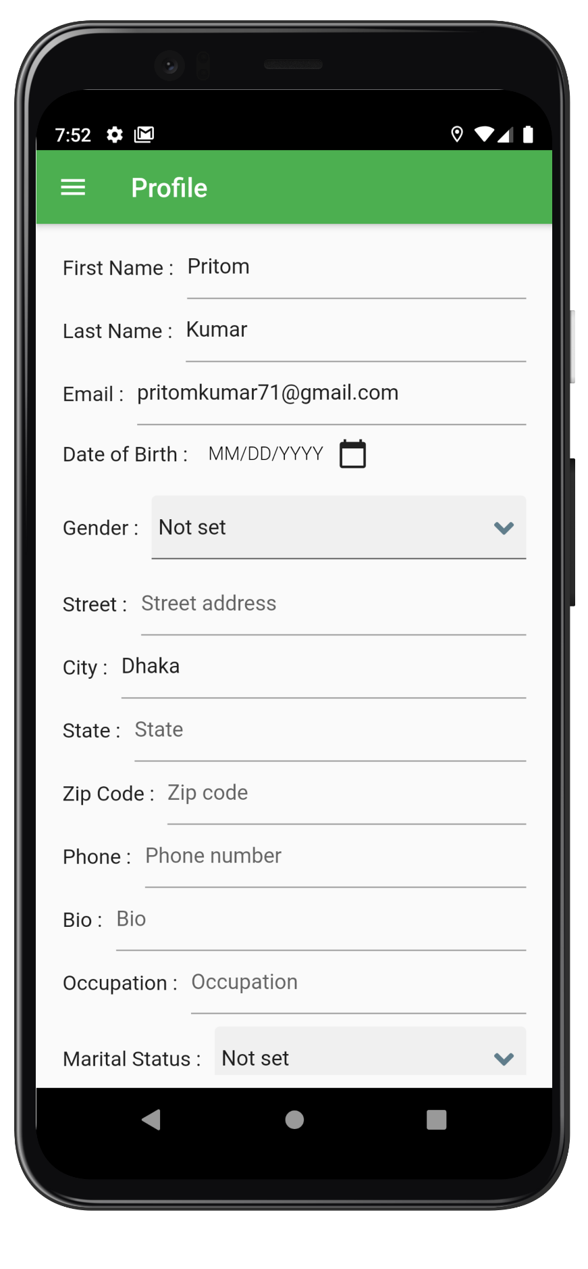

Figure Profile Page

This is the profiles page. User can edit their personal information here. Some of the information is already fillup by taking it from their publicly available email.

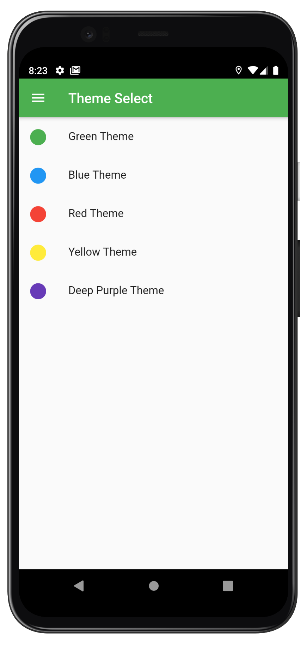

Figure Theme Page

This is the theme selection page.

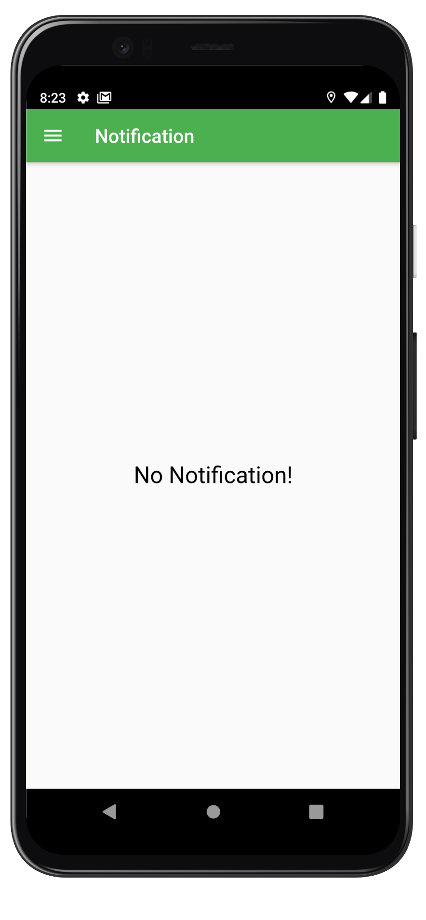

Figure Notification Page

This is the notification page. All notification appears here first. At first there is no new notification But it gets new notification after getting assigned a task or receiving payment.

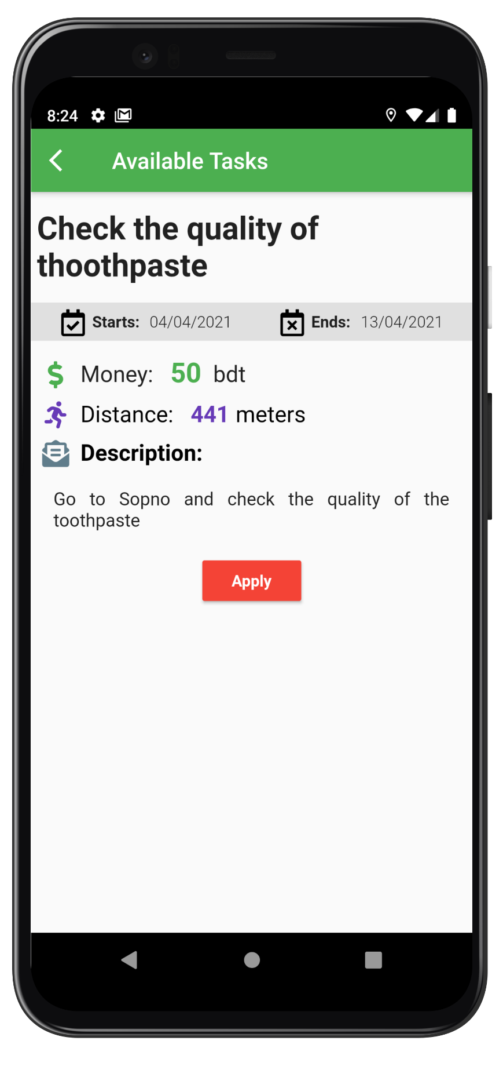

Figure Available Task Page

This is the available task page. It holds all the necessary information for a user to start their application. They can apply for the task by tapping the apply button.

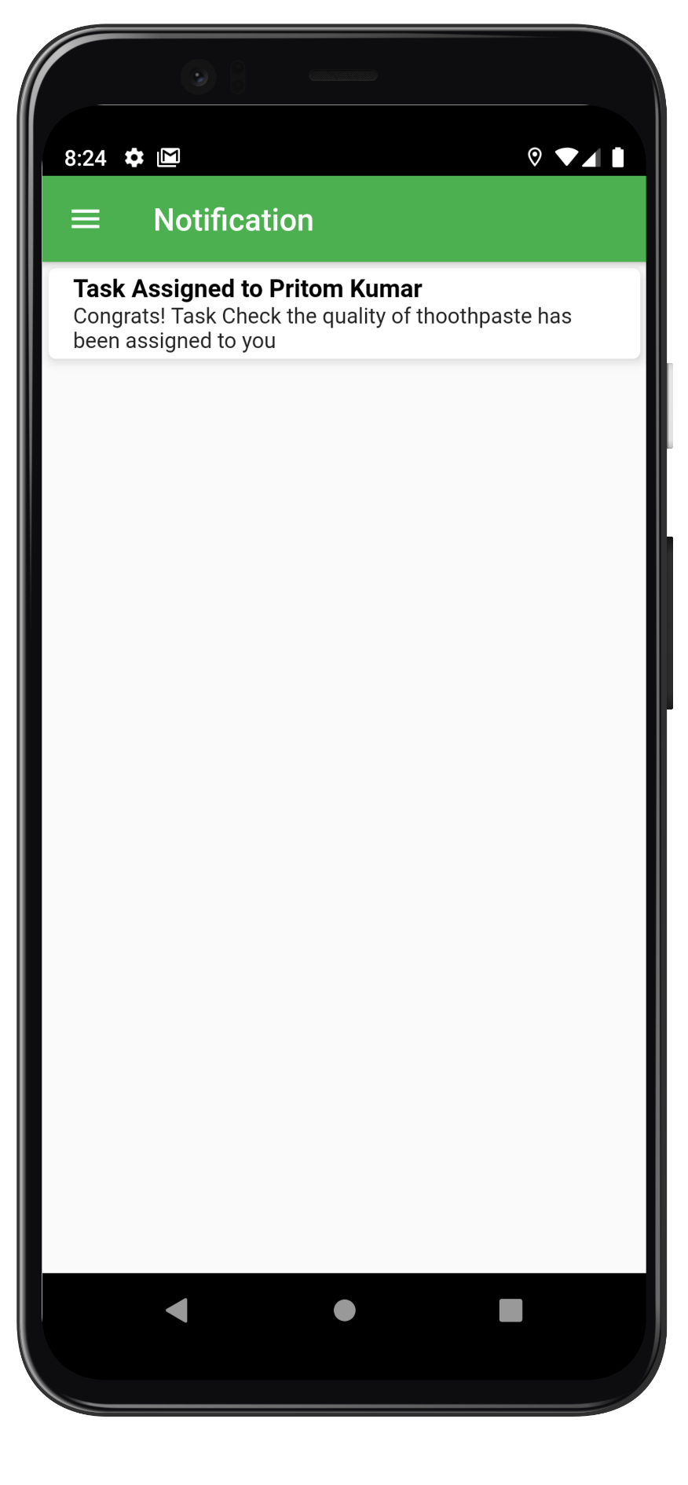

Figure Notification With Notificaiton

After applying for the task the user will receive this notification if he/she is eligible for the task. The user can delete notification by swiping left or right.

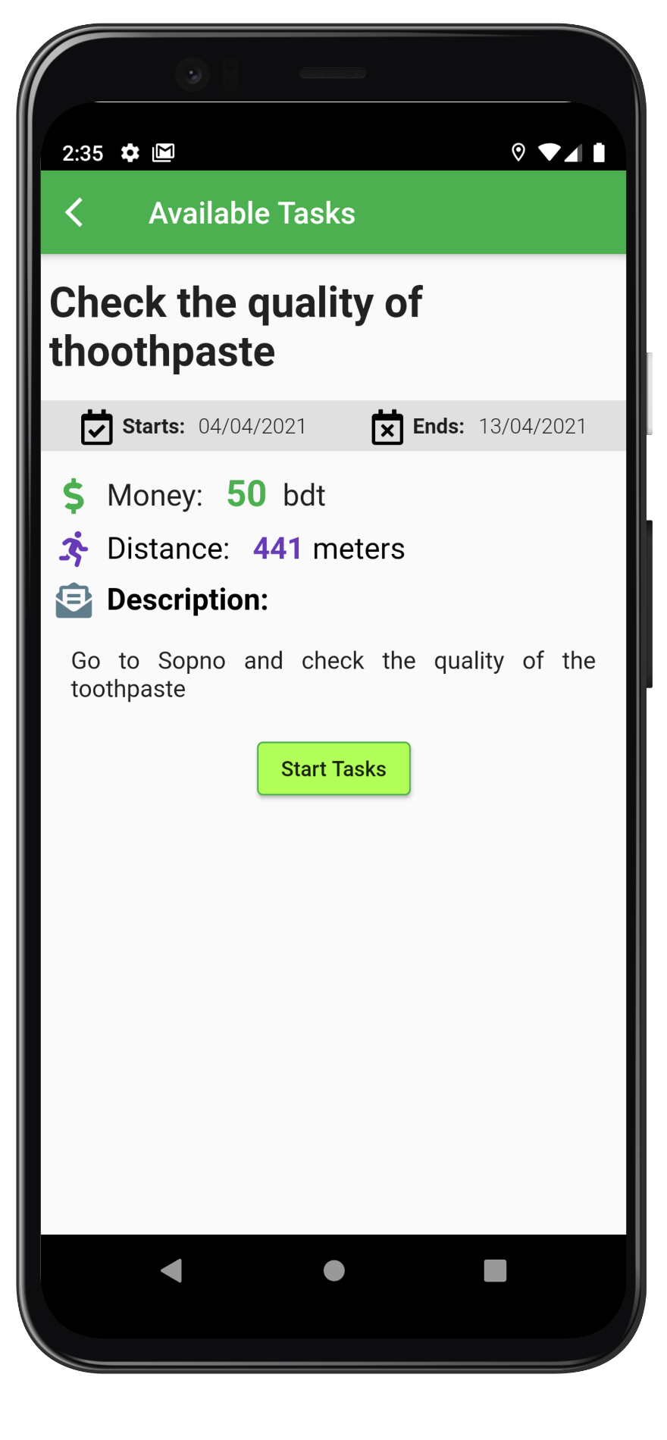

Figure Start Task

This Start Tasks button will appear after going to the same page.

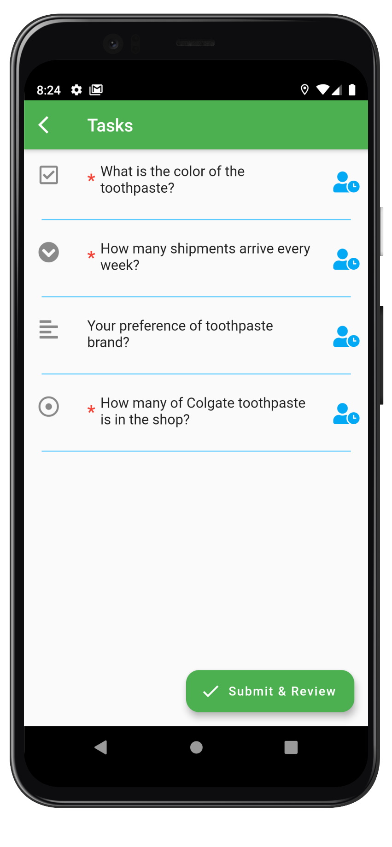

Figure Task List Page

This is the task list page and the user can see the available tasks from this page. By clicking the submit and review button the next prompt appears.

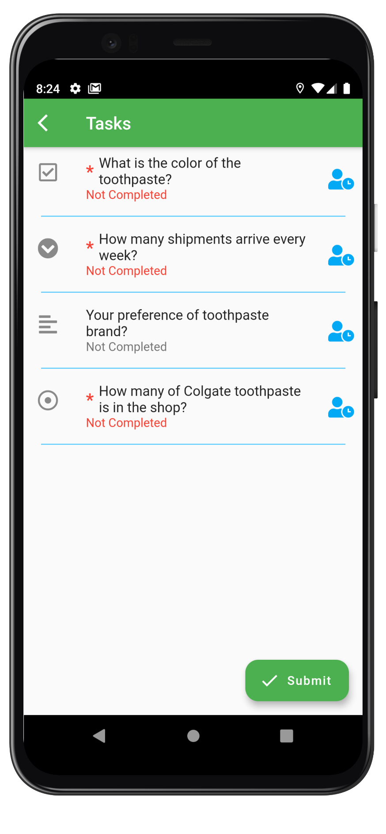

Figure Submit and Review check

By clicking the submit and review button the users can see which tasks are completed and which must be completed. The required tasks start with a red star before the subtask. The type of task can be seen at the side of the task.

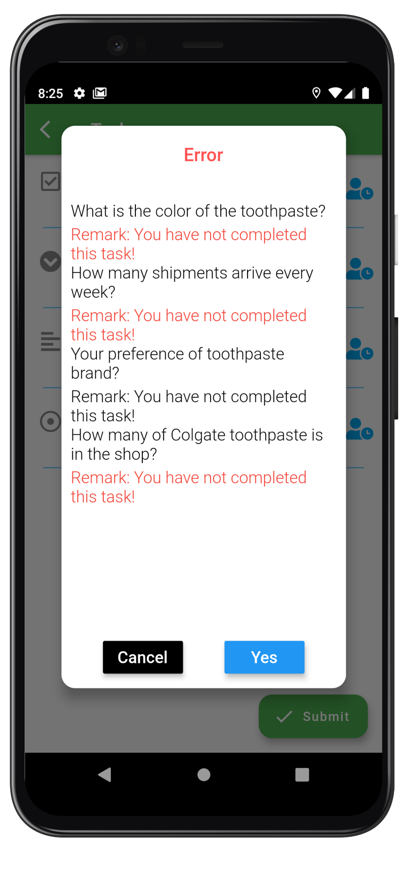

Figure Error function check

If the user does not complete the required task and tap submit this error page appears and tells the user the tasks that are missing with appropriate remark. Below are various types of task for this application.

This is the multiple choice task and free text task

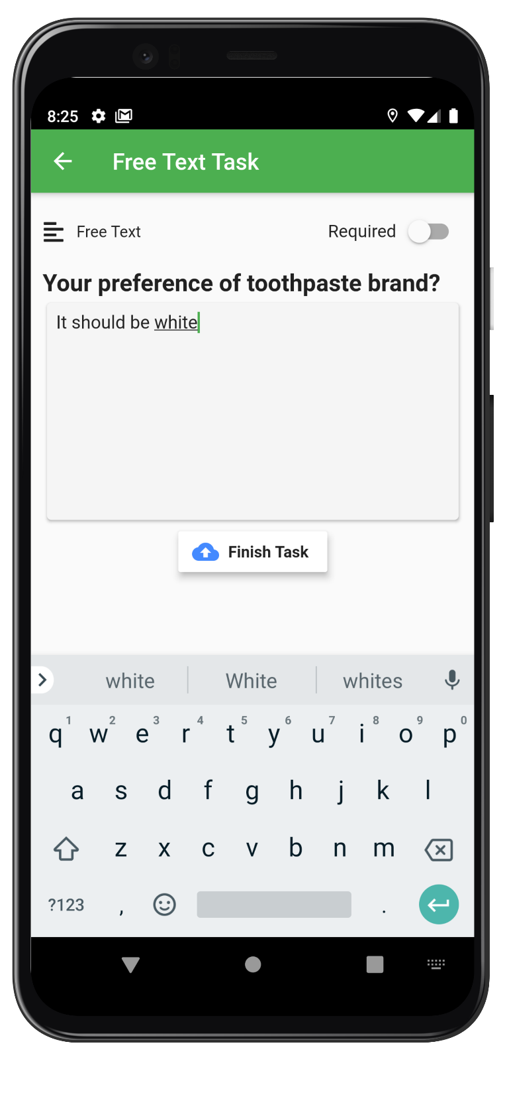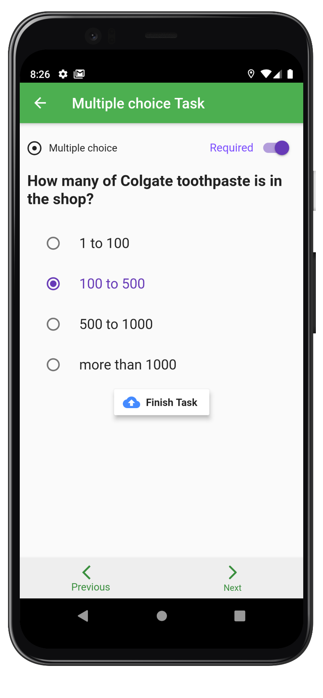

Figure Free Text Task

Figure Multiple Choice task

This is the check box task and dropdown menu task

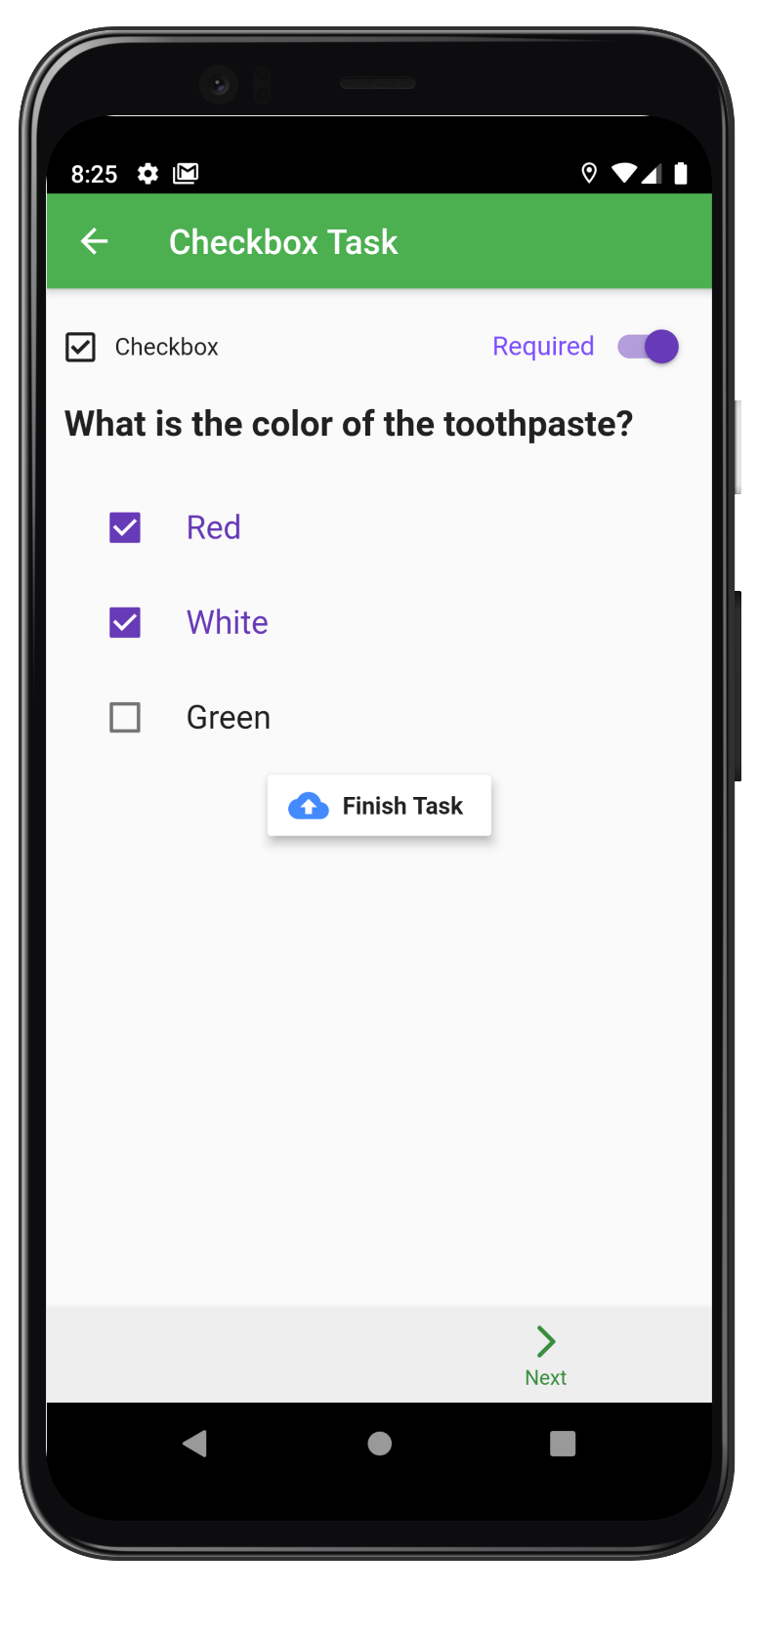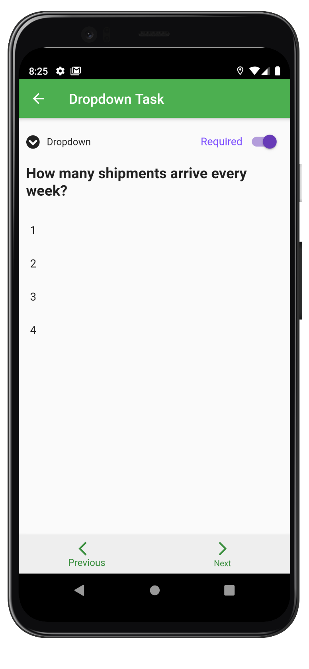

Figure CheckBox Task

Figure Dropdown Task

This is the image task page. It also requires permission to use camera and photos.

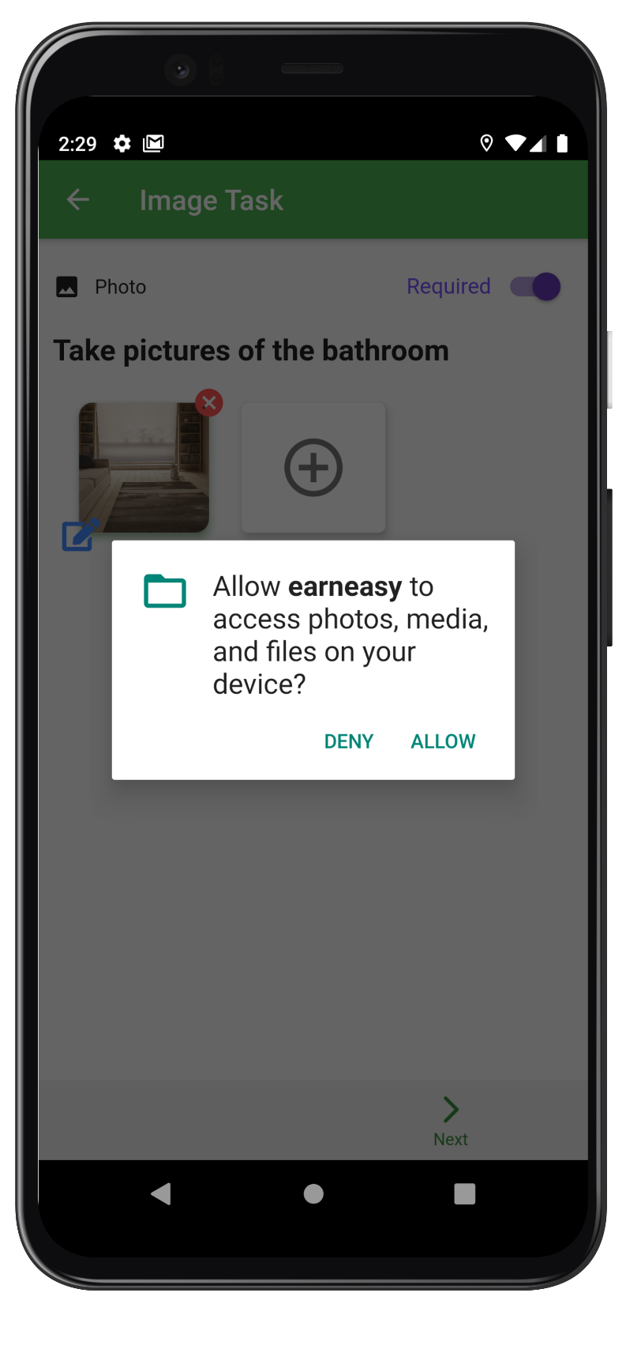

Figure Device camera Permission

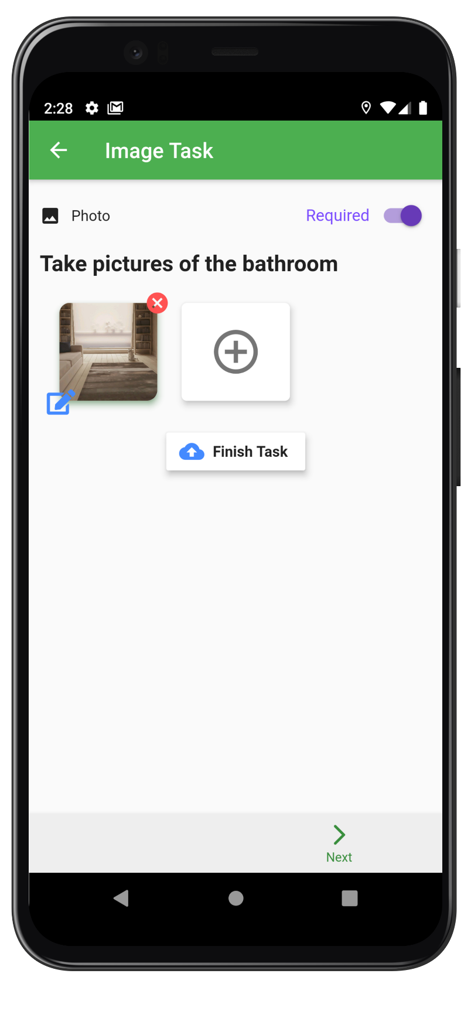

Figure Camera select

The user can choose to use camera or gallery and can also edit their photo.

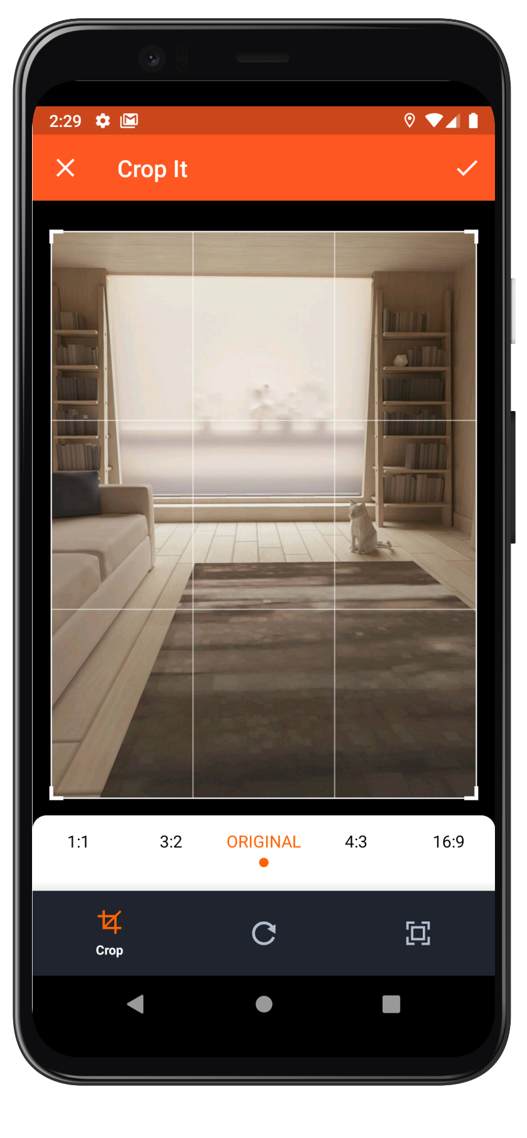

Figure Image manipulation

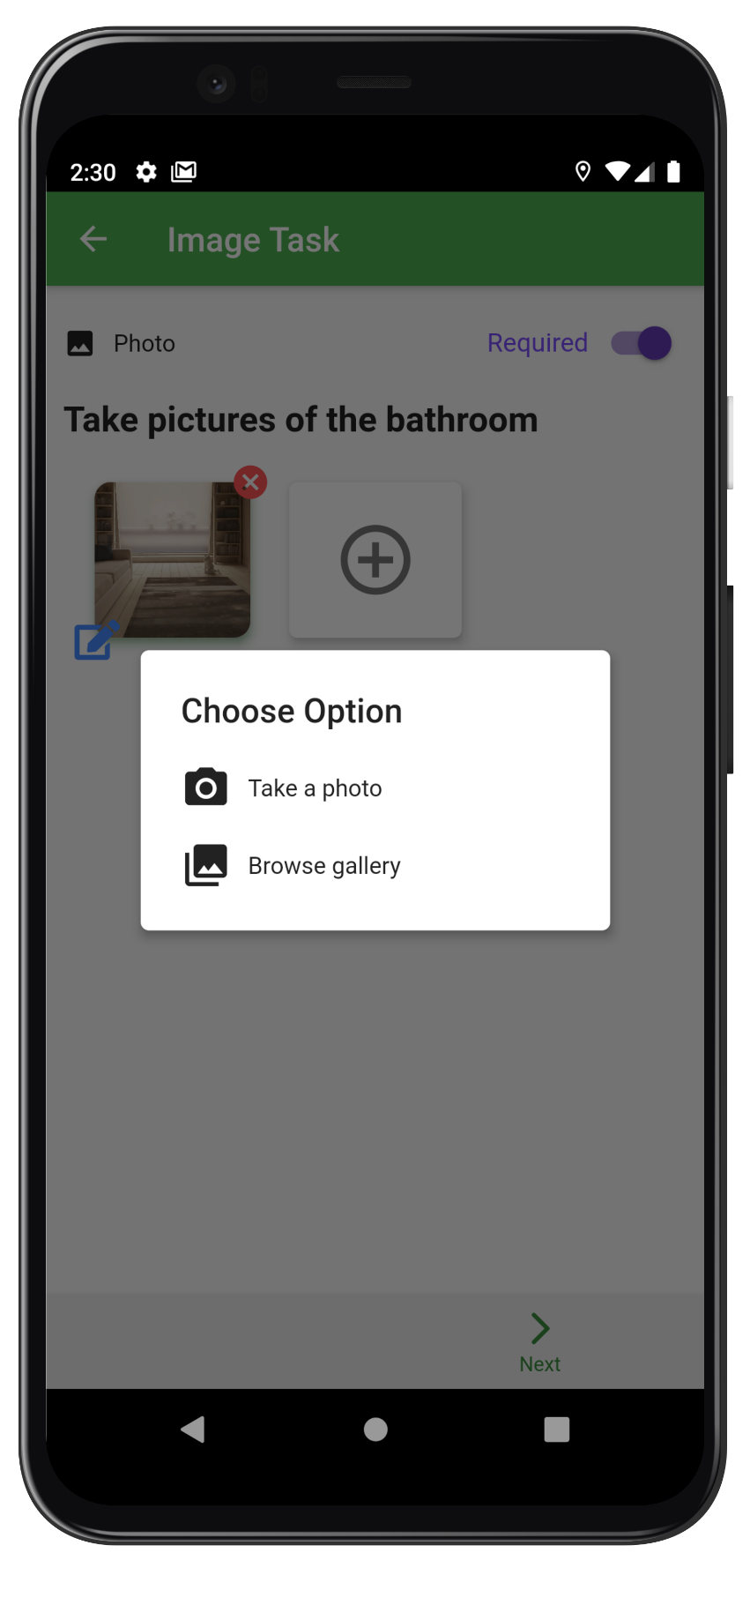

Figure Option for Image

After finishing the task task list page looks like this. Then the user can submit the task without any issue.

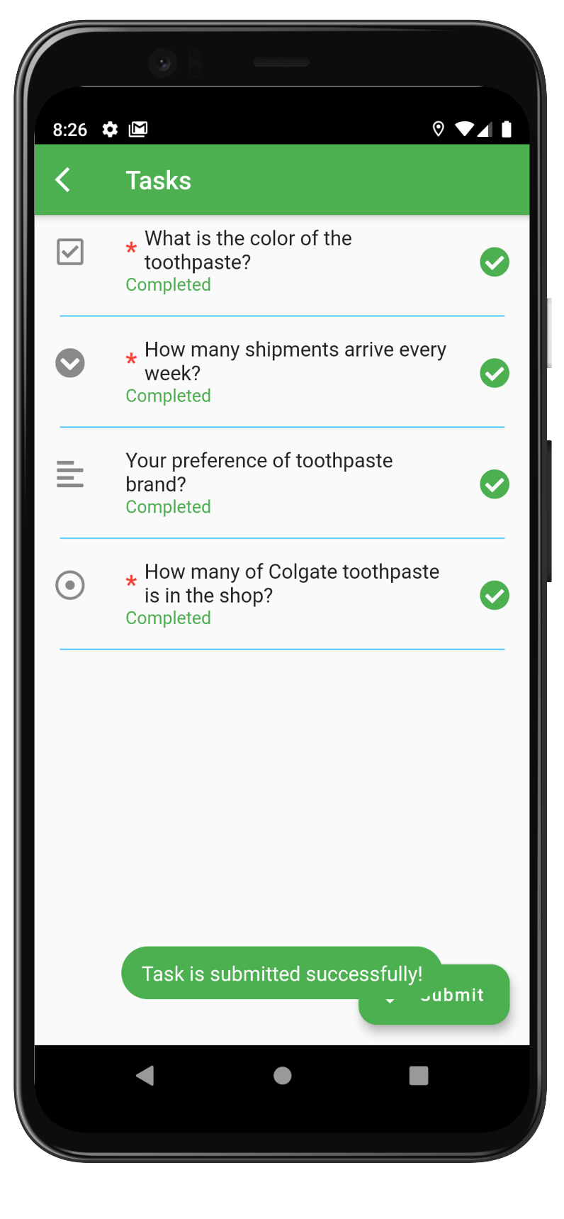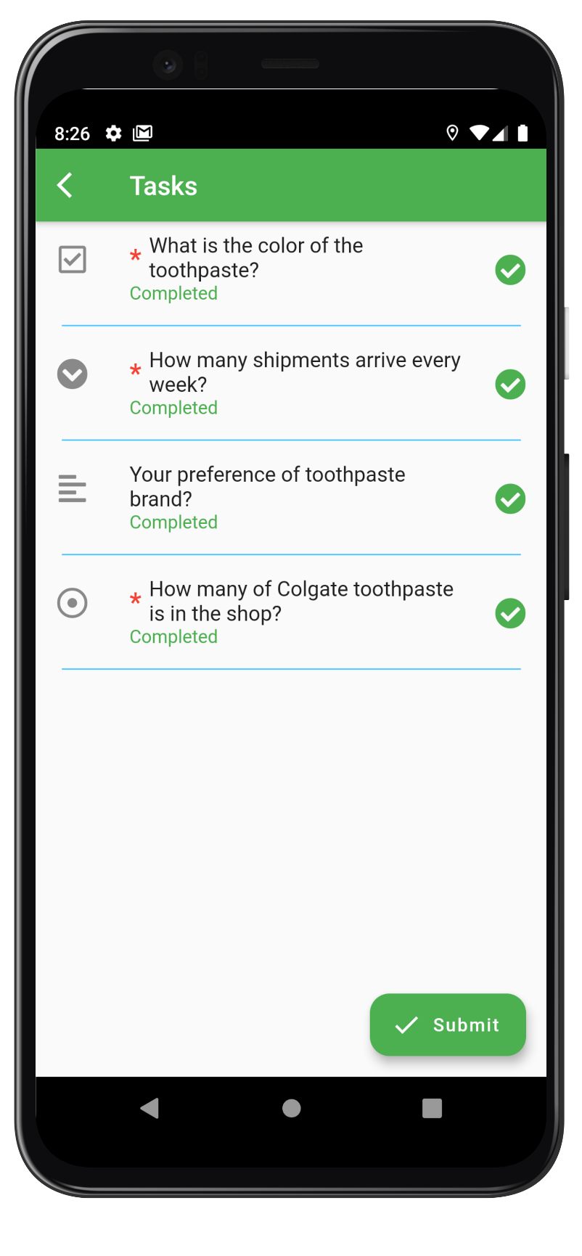

Figure Task Submit

Figure Task List after task completeion

## COMPANY APPLICATION

The company is the one that creates the tasks. This is the part of the application that’s only available to the companies.

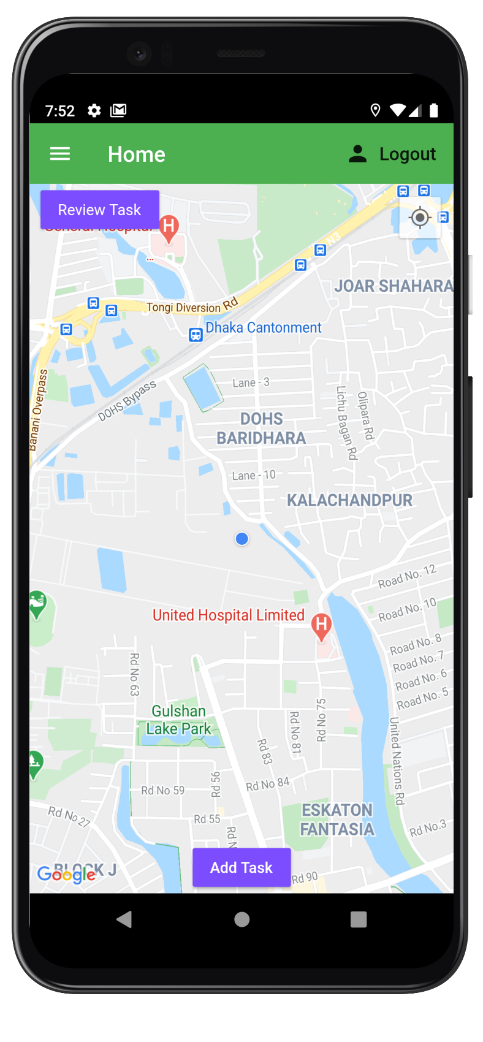

Figure Home Page (Company)

This is home page for companies. They can tap add task to add a task and review task to review a submitted task.

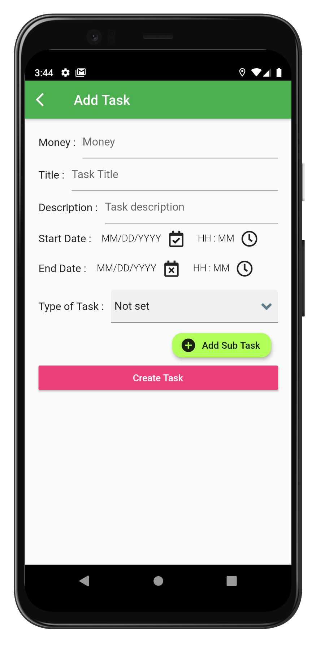

Figure Create Task page

This is create task page for the companies. They can fill up all the information here to finalize the task.

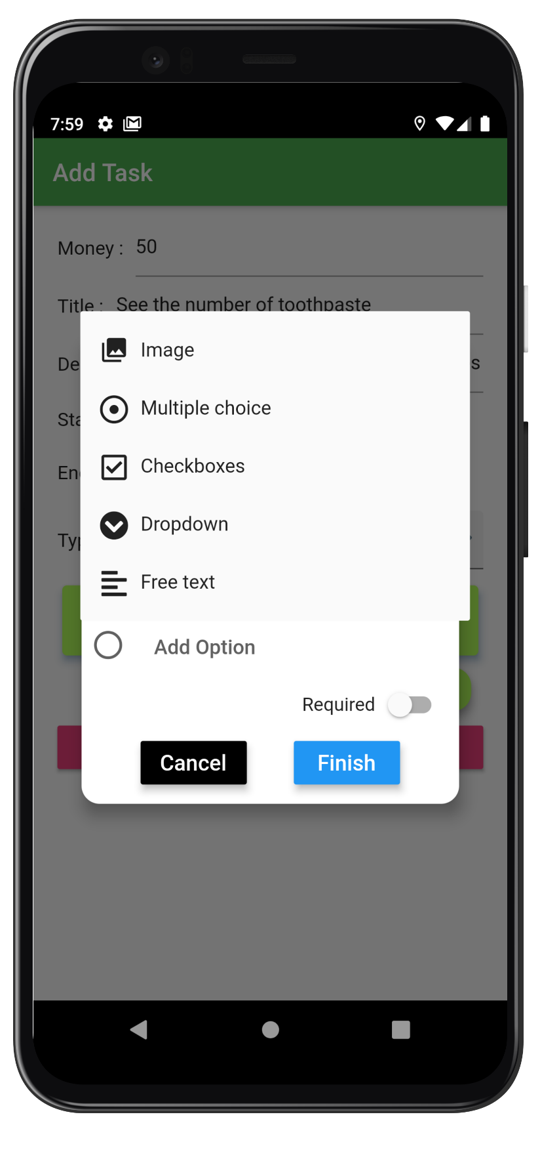

Figure Subtask selection

Add subtask method lets the user choose any subtask from the choice list. It is really intuitive and follows the google form format.

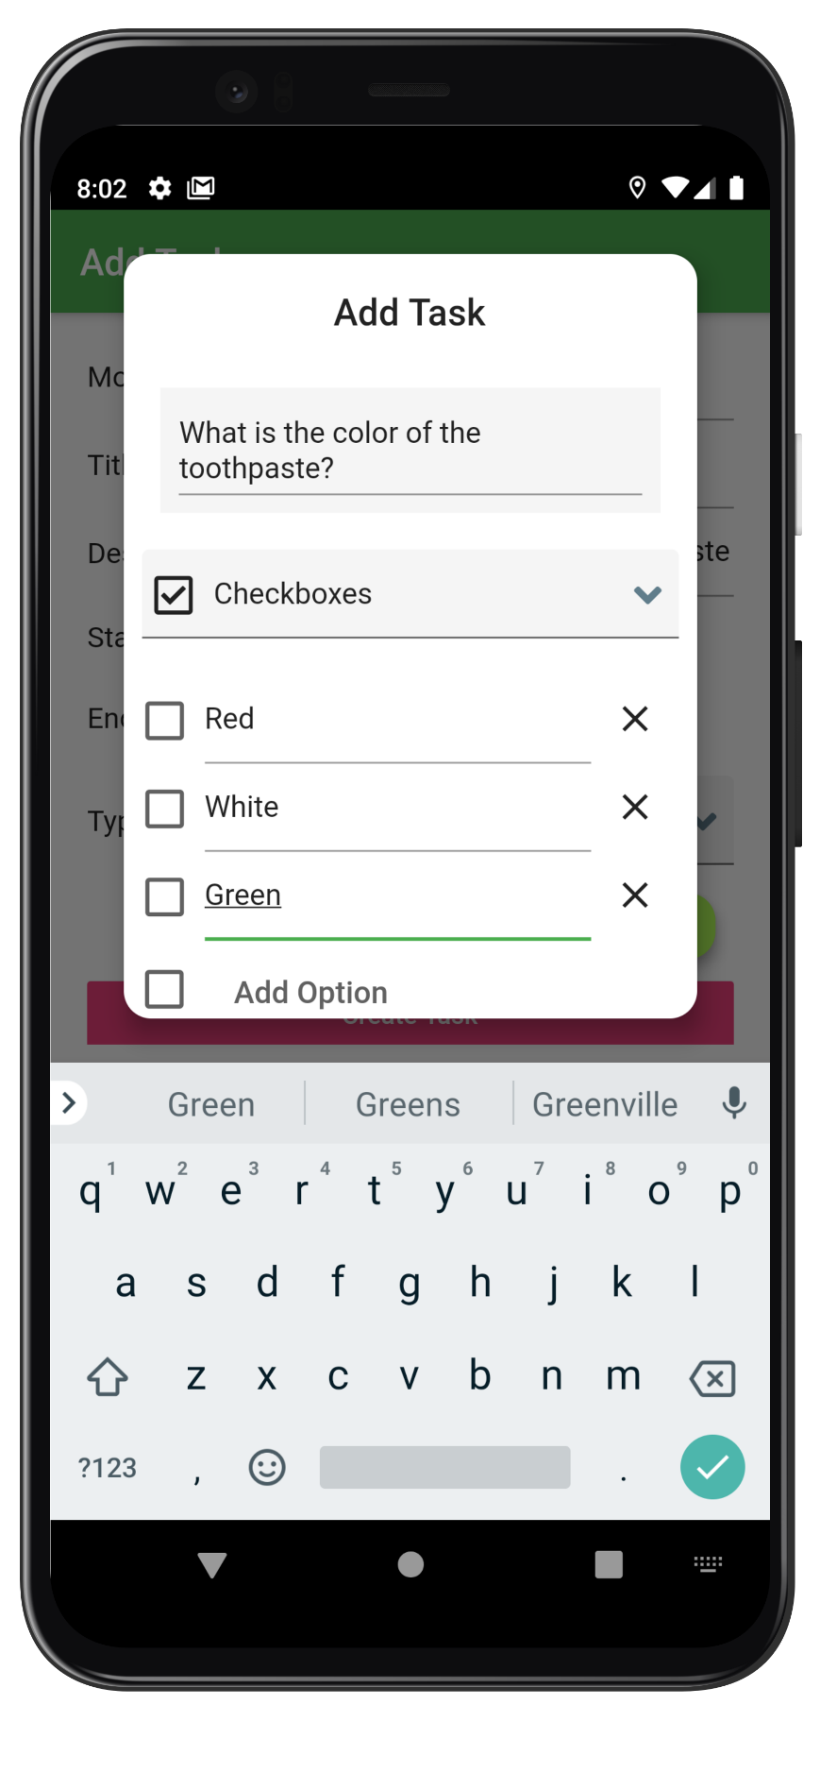

Figure Option selection

Adding options for a task can be done really easily just by tapping on the options. The user can also remove any option by tapping the remove icon.

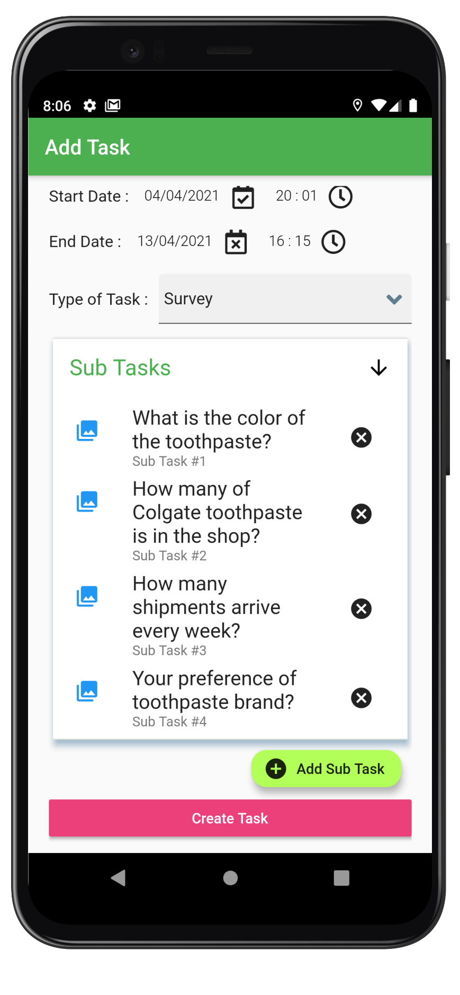

Figure Task FInal

The user can make a final change in the subtask menu button before finally tapping create task. After that the task is available to the members and they can finish it

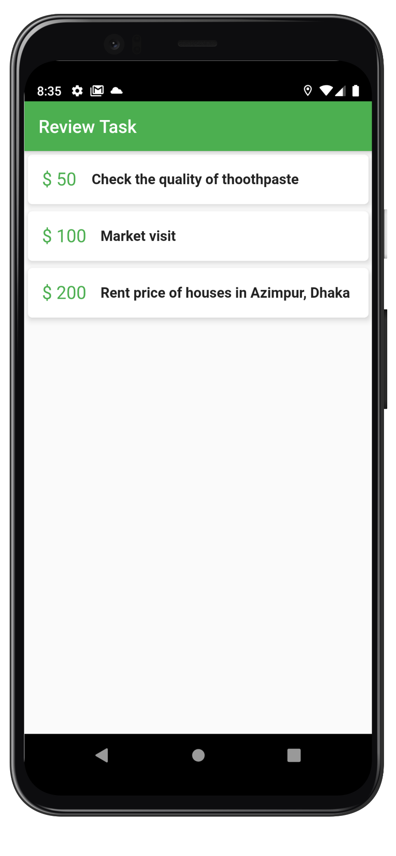

Figure Task Review Page

By tapping the review task button the companies can check if any is completed. If so they can review it.

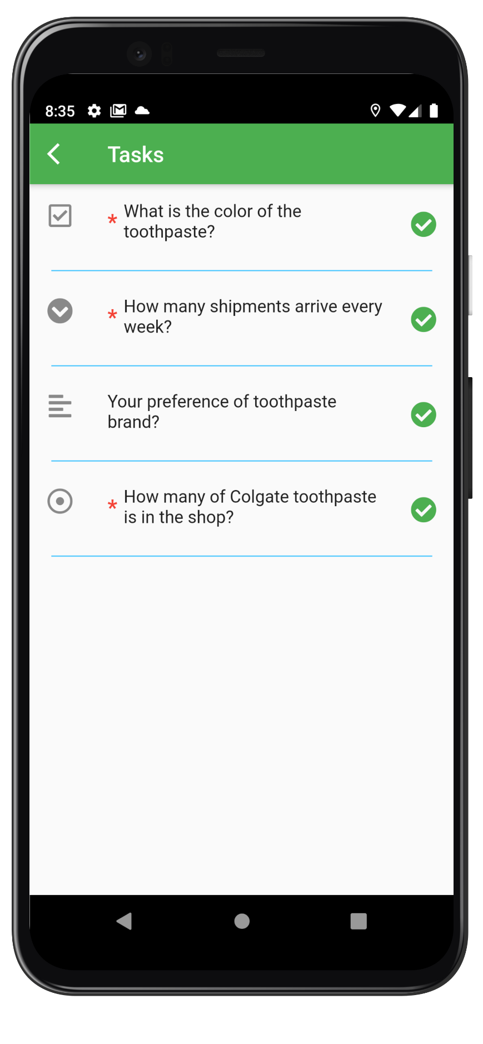

Figure Task Review List

Similar to member page but the company can only see the finished task.

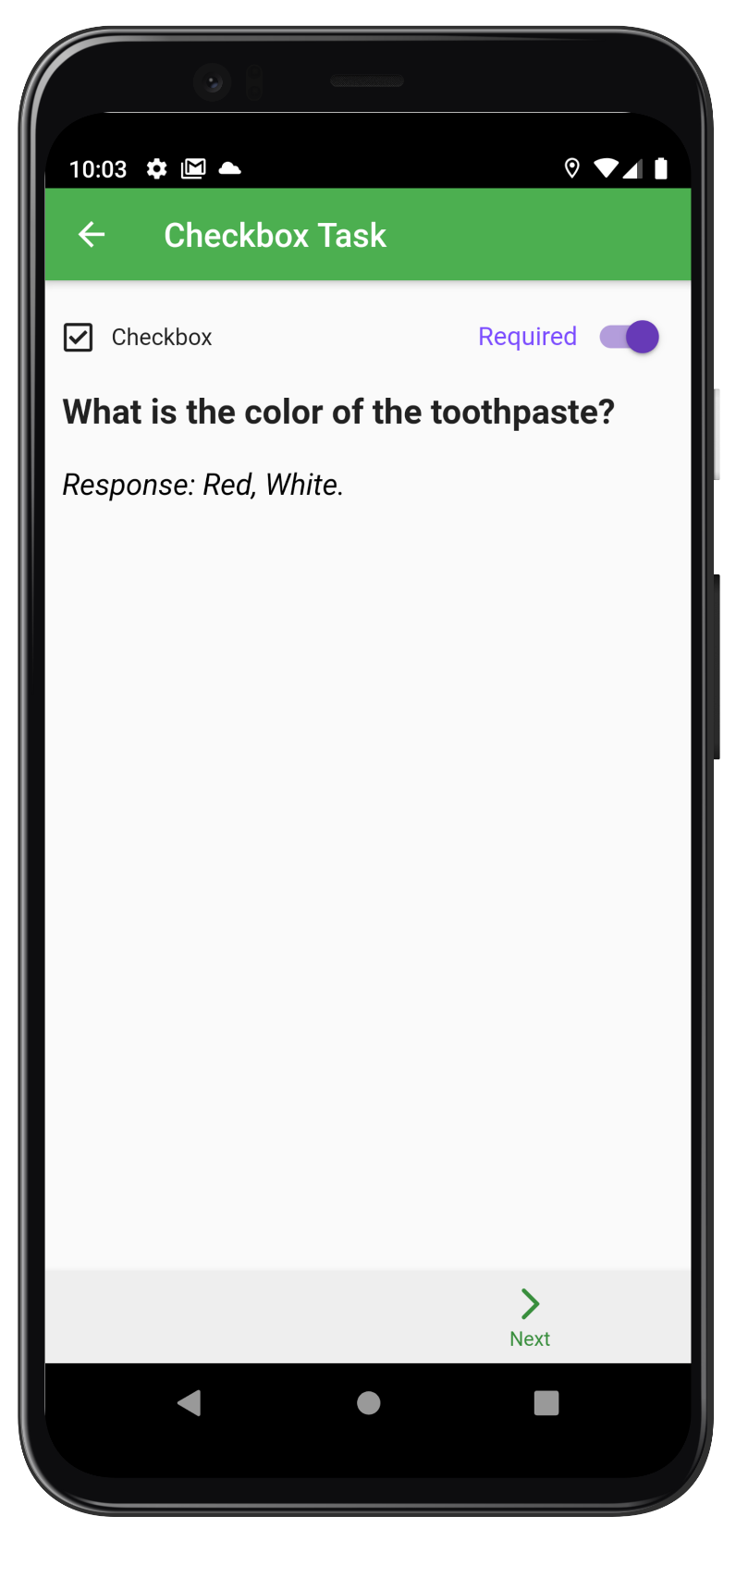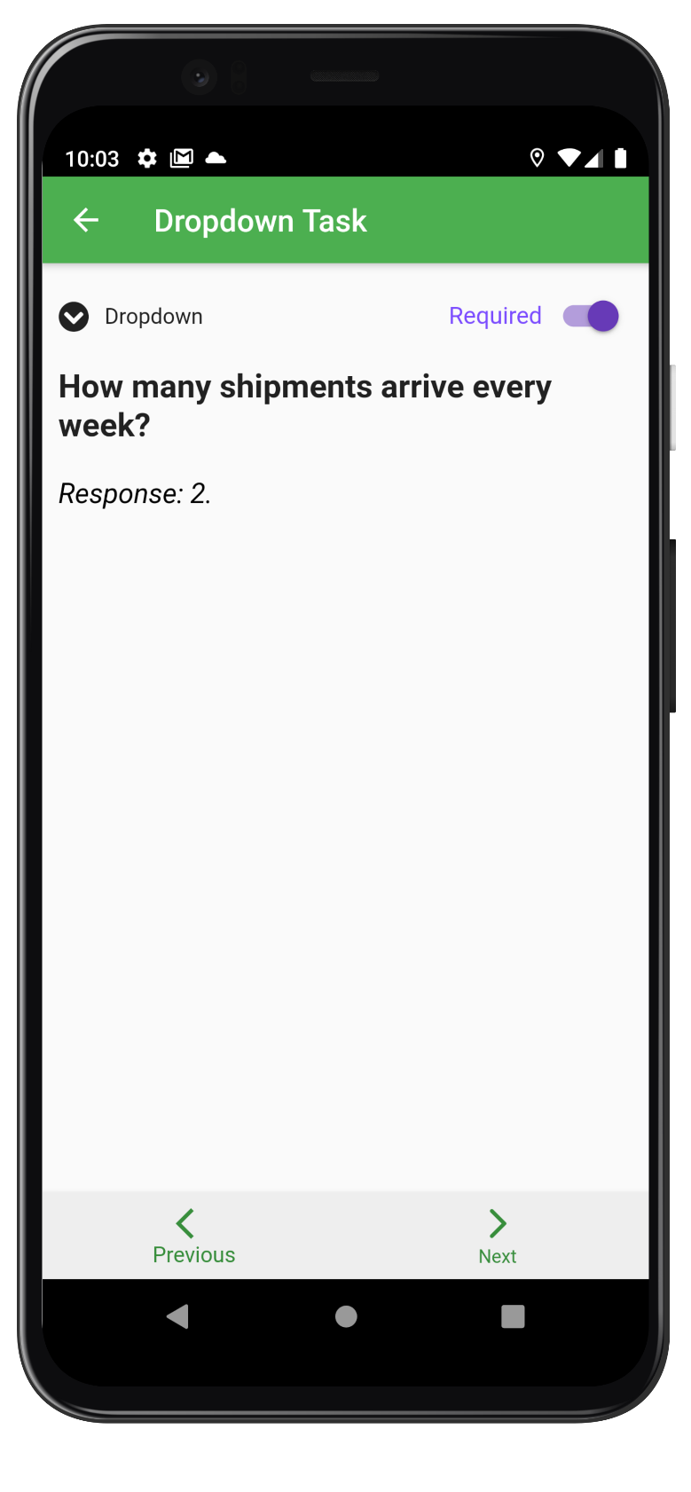The check box task response and dropdown task response.

Figure Checkbox task Response

Figure Dropdown Task Response

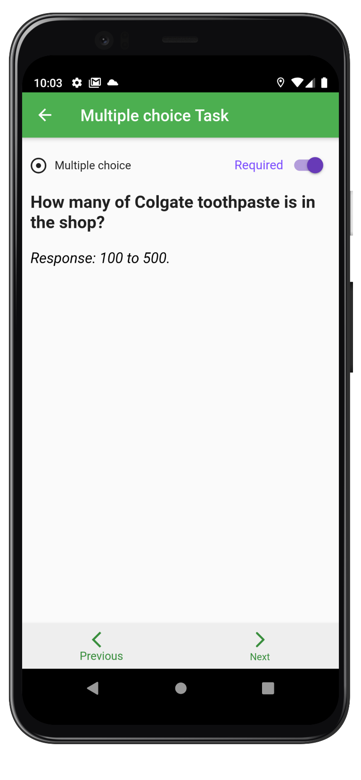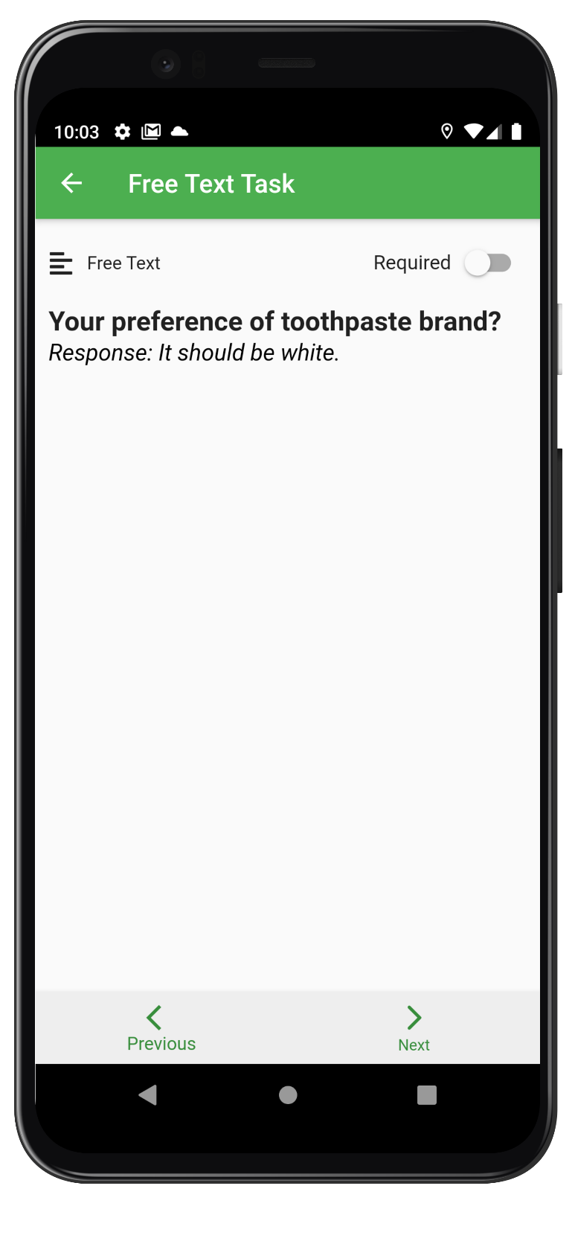The free text task response and multiple choice task response.

Figure Multiple Choice Task Response

Figure Free Text Task Response

# REFERENCES

1. A Review of Mobile Crowdsourcing Architectures and Challenges: Towards Crowd-Empowered Internet-of-Things . *Published in: IEEE Access , 07 December 2018*
2. A Survey on Security, Privacy, and Trust in Mobile Crowdsourcing . *Published in: IEEE Internet of Things Journal ( Volume: 5 , Issue: 4 , Aug. 2018 )*
3. CrowdEIM: Crowdsourcing Emergency Information Management Tasks to the Mobile Social Media Users . *Published in: 2019 ACM/IEEE Joint Conference on Digital Libraries (JCDL) . Date of Conference: 2-6 June 2019*
4. Thebault-Spieker, Terveen, & Hecht. Avoiding the South Side and the Suburbs: The Geography of Mobile Crowdsourcing Markets. *Published - Feb 28 , 2015*
5. CrowdDBS: A Crowdsourced Brightness Scaling Optimization for Display Energy Reduction in Mobile Video  *Published in: IEEE Transactions on Mobile Computing ( Volume: 17 , Issue: 11 , Nov. 1 2018 )*